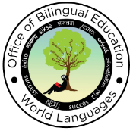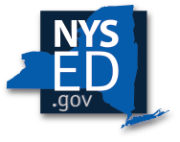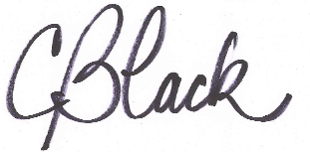c

Elisa Alvarez, Associate Commissioner

Office of Bilingual Education and World Languages

New York State Education Department

Candace R. Black, World Language Associate

Office of Bilingual Education and World Languages

New York State Education Department

## This certifies that

**­­­­­­­­­­­­­­­_________________**

has fulfilled all of the requirements to earn

the New York State Seal of Biliteracy

for the academic school year 2023-2024

by demonstrating a high level of proficiency in English and in two other World Languages.

# **Office of Bilingual Education and World Languages**

**New York State Education Department**

**Certificate of Excellence**