Batch Process PDF Files for Accessibility – Running a Batch File
- Open a PDF file in Adobe Acrobat
- Click Tools > Action Wizard
- Under Actions, click on a new action to run
- Under Files to be processed, click the Add Files icon
- Select files to process. Folders can be selected
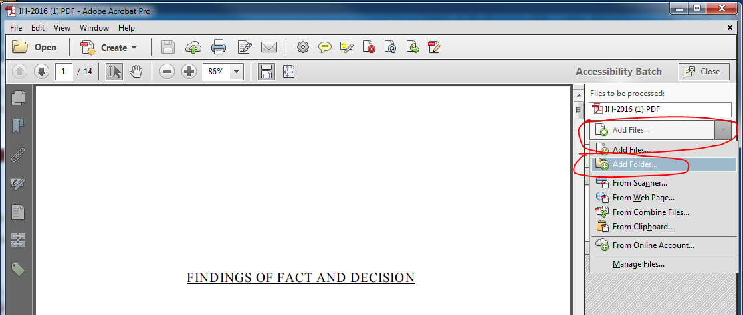

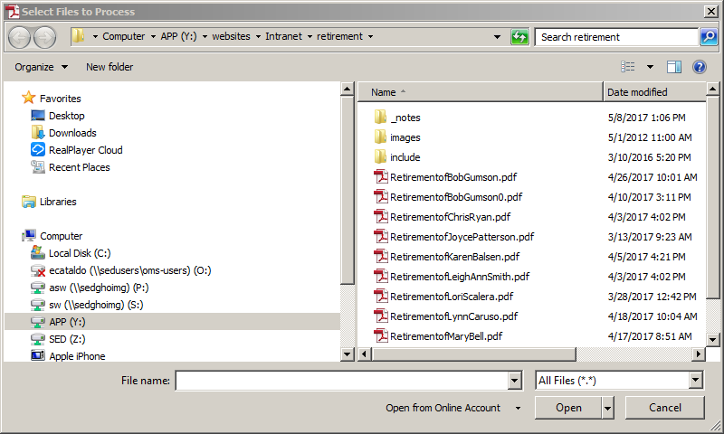

- Once the files are selected click on Start and it will automatically process all of the files.
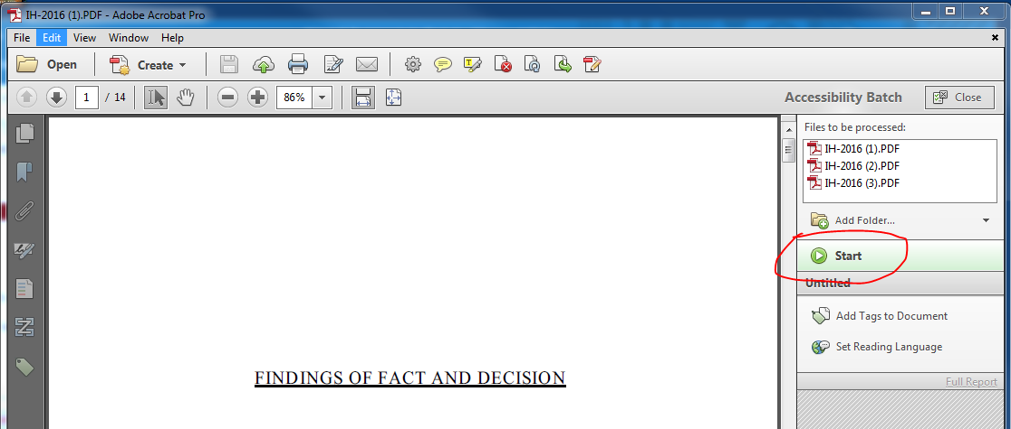

- Once the action is completed, and it has worked correctly, then each file and action will have a green checkmark.
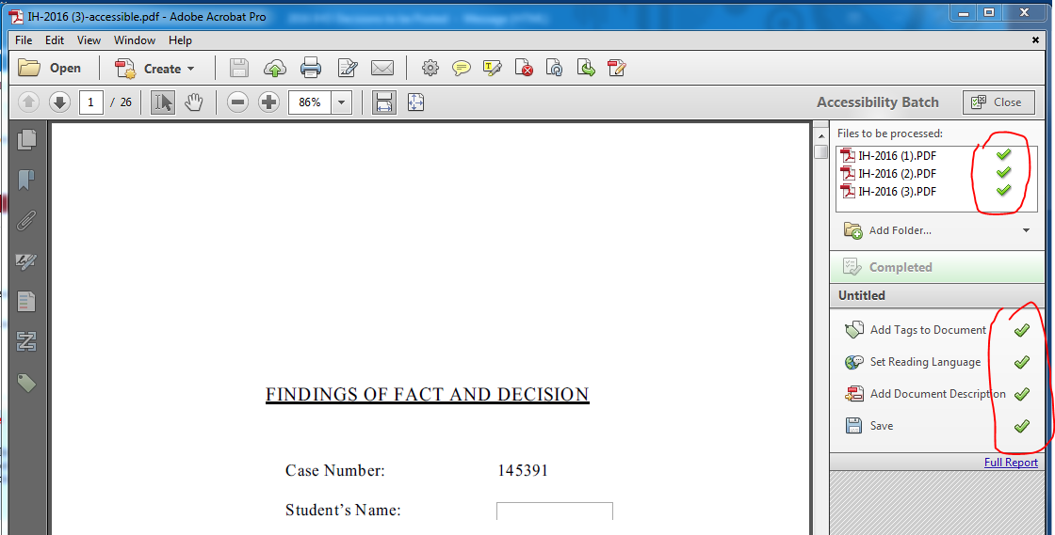

- Although the documents properties are updated by this process, when running the Full Accessibility check, the document Title will still often fail.
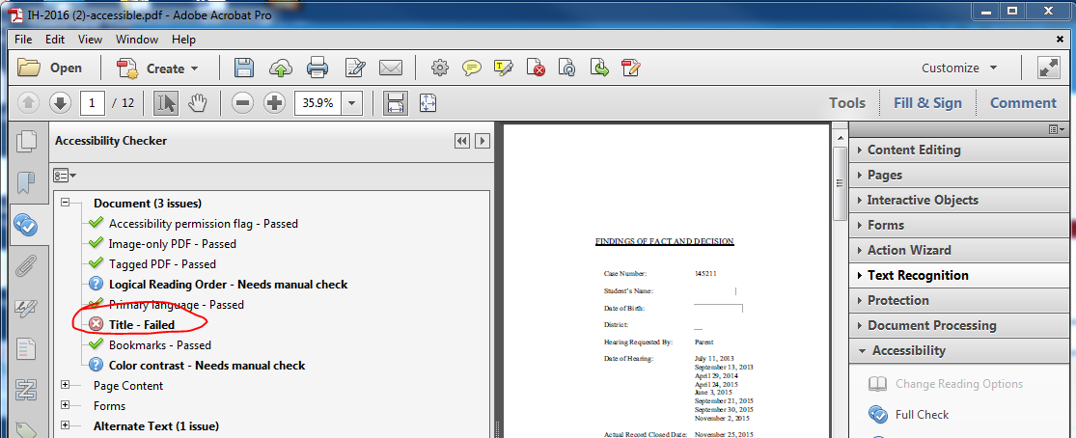
- However, if you right click on the Document-Title you can select “Fix” and then it will recognize the settings (title, subject, keyword and author) that this batch action automatically updated.
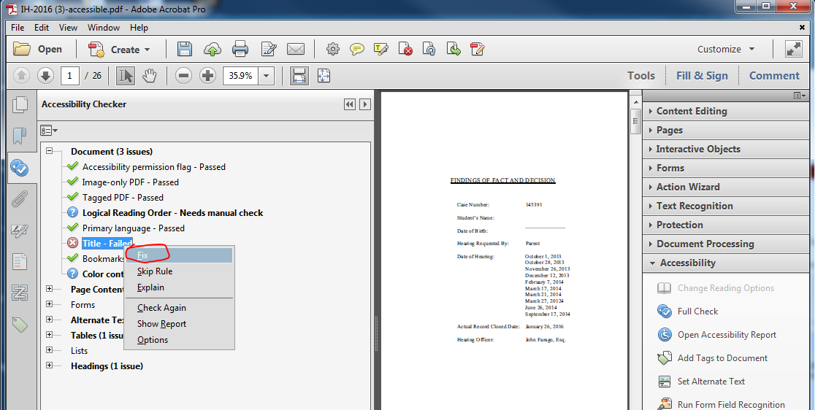

- The action is saved in your local Adobe Acrobat settings and can be modified by right-clicking on the action.
