Batch Process PDFs for Accessibility

- Open a PDF file in Adobe Acrobat

- Tools > Create New Action…

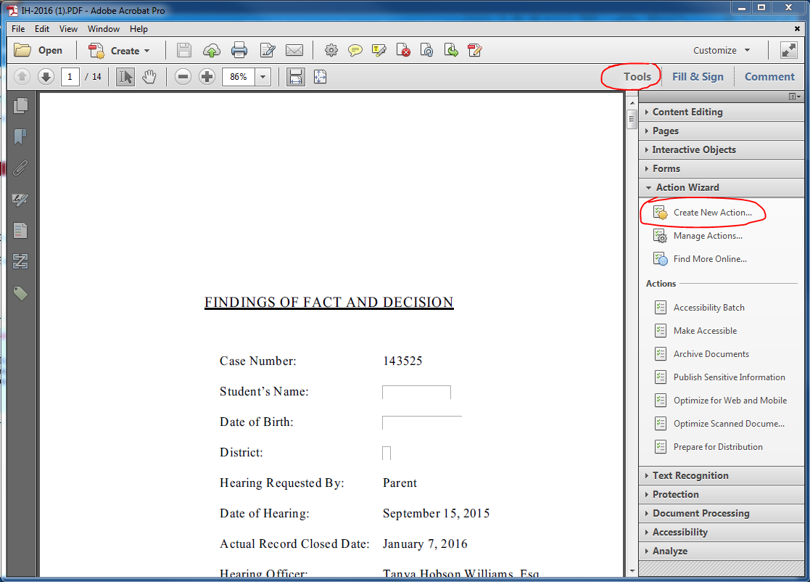

Add Tags to Document
- In the left-hand section, under Choose tools to add: > Accessibility, click to select Add Tags to Document
- Click the move icon which is located between the 2 sections.
- The action will appear in the right-hand section, under Action steps to show: > Untitled.
- Click Save
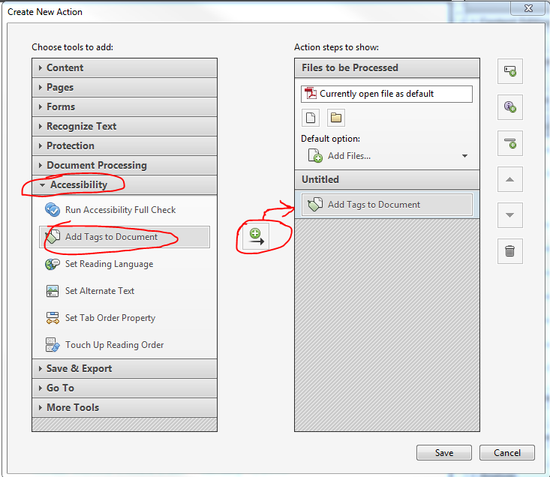

This action should only be used on PDFs that are missing tags. If this action is run on previously tagged PDFs it will replace those tags with a new set of tags which could be an issue if the previous tags were already in an accessible format.

Setting the Reading Language
- In the left-hand section, under Choose tools to add: > Accessibility, click to select Set Reading Language
- Click the move icon which is located between the 2 sections.
- The action will appear in the right-hand section, under Action steps to show: > Untitled.
- Click Specify Settings
- In the Set Reading Language window, make sure English is selected.
- Click OK
- Be sure to uncheck prompt user so it will go automatically if they are all English documents.
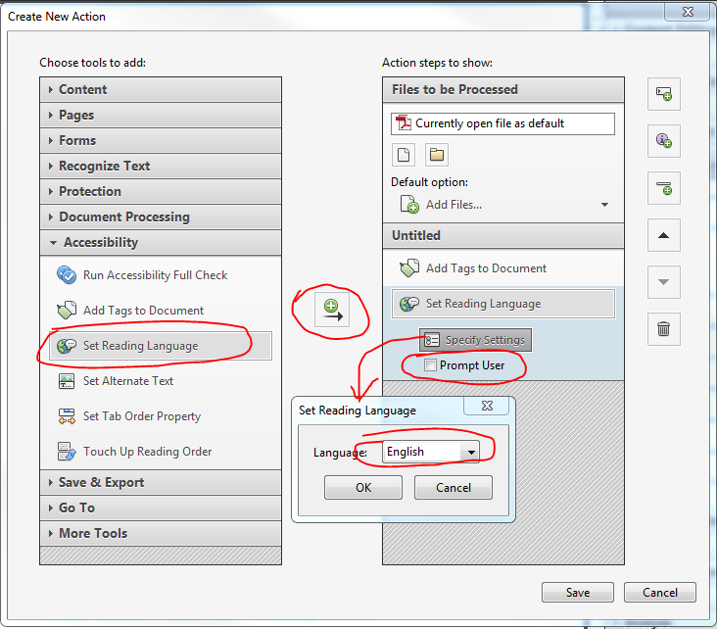

Add Document Properties
- In the Create New Action window, under Choose tools to add: click Content > Add Document Description.
- Click the move icon which is located between the 2 sections.
- Click Specify Settings
- Title and author are required for NYSED’s minimum accessibility requirements. Author should always be set to “New York State Education Department” unless the document was authored by an outside individual or organization). Subject and keywords are also recommended. If multiple documents are going to be tagged with different titles set the
- Author should always be set to “New York State Education Department,” unless the document was authored by an outside individual or organization.
- Be sure to uncheck prompt user
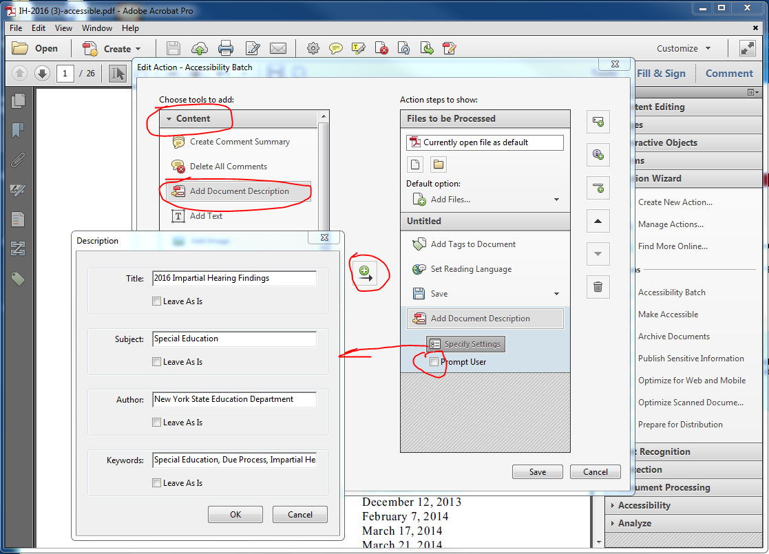

Set action to Recognize Text Using OCR and use the default settings:
- Primary OCR Language: English (US) - or change as needed
- PDF Output Style: Searchable Image
- Downsample to: 600 dpi
- Be sure to uncheck prompt user so it will go automatically.
Important: if a document has one character of text on a page then the OCR scan will skip the page. Therefore, it is important to manually review documents to ensure that all image based text has an accessible text version.
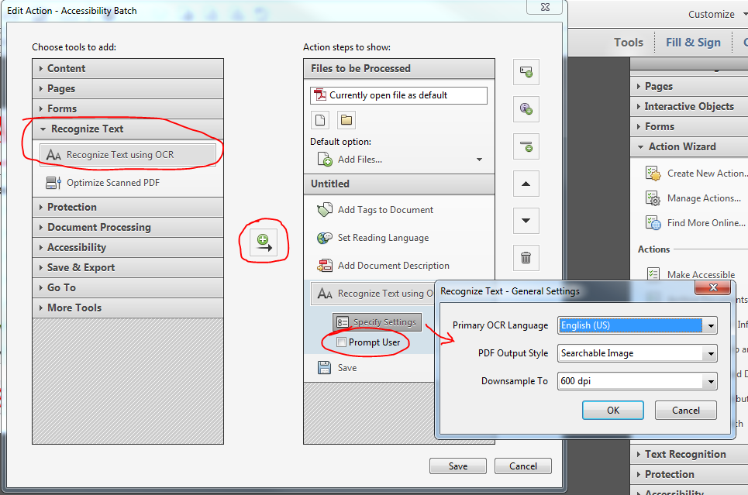

Set Open Options
- In the left-hand section, under Choose tools to add: > Document Processing, click to select Set Open Options
- Click Specify Settings
- In Set Open Options box, under Window Options select Yes to Display Document Title. Under Open Action select magnification = 100%.
- Be sure to uncheck prompt user so it will go automatically.
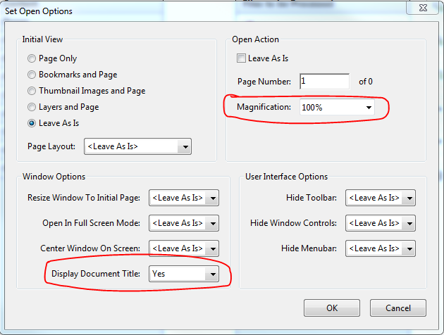

Add Save as an Action
Add Save as an action so that each file we automatically save and the process will continue automatically on all files selected. Files can be overwritten with the same name or you can add text such as “-accessible” to the new versions of the files.
- In the Create New Action window, under Choose tools to add:, click Save & Export > Save.
- Click the move icon which is located between the 2 sections.
- Click Specify Settings
- In Output Options box, under File Naming, click to select Add to original file names:
- Under Insert After, type -accessible
- Click OK
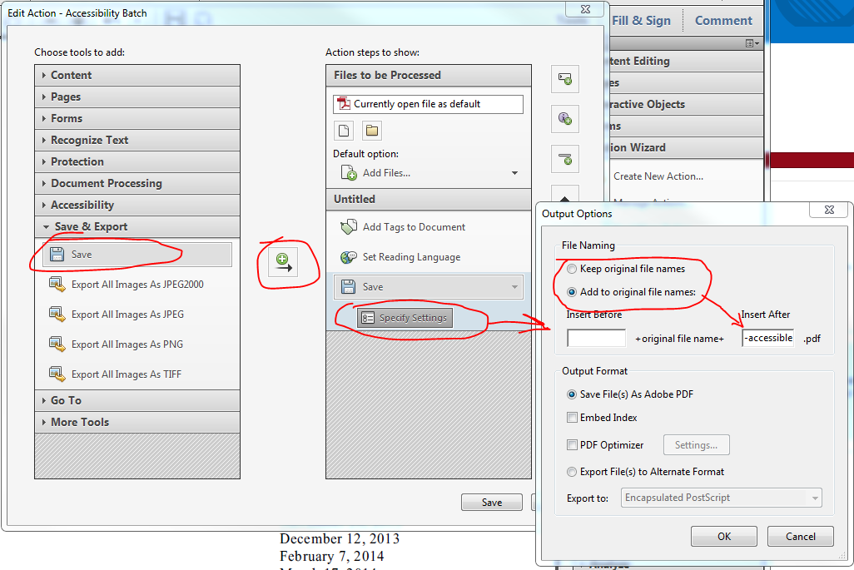

- The action will now have the added processes listed:
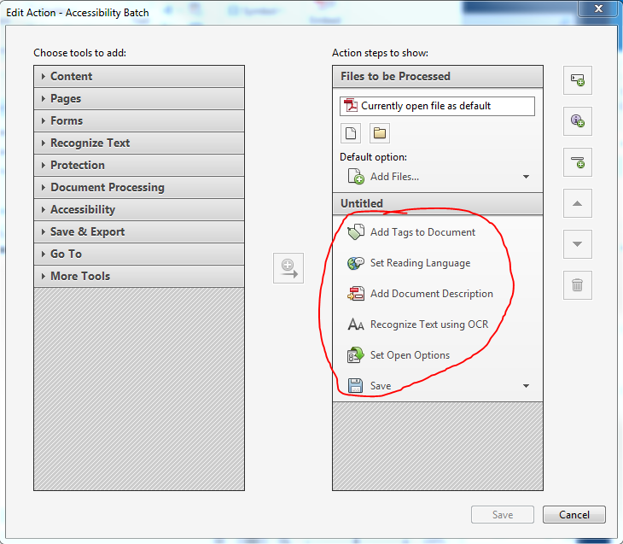

Save Action Wizard
- Click Save
- In the Save Action window, type in an Action name. It can be “Accessibility Batch” or anything you'd like.
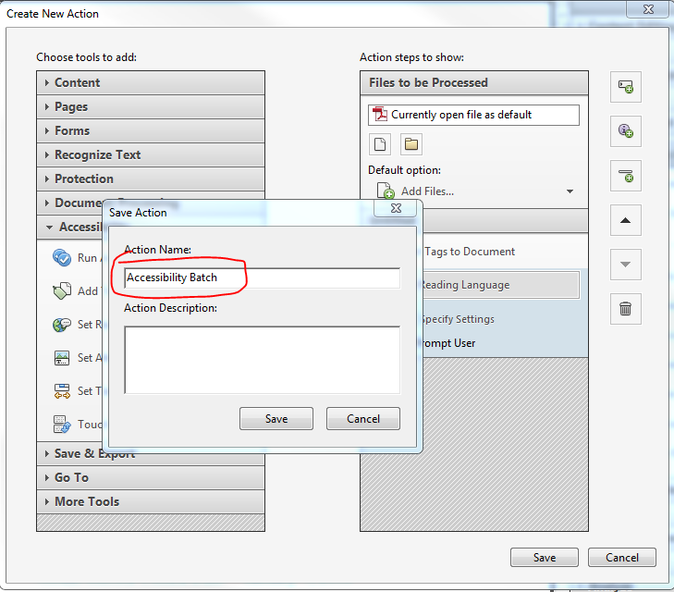

The new action will be listed under Tools > Action Wizard > Actions

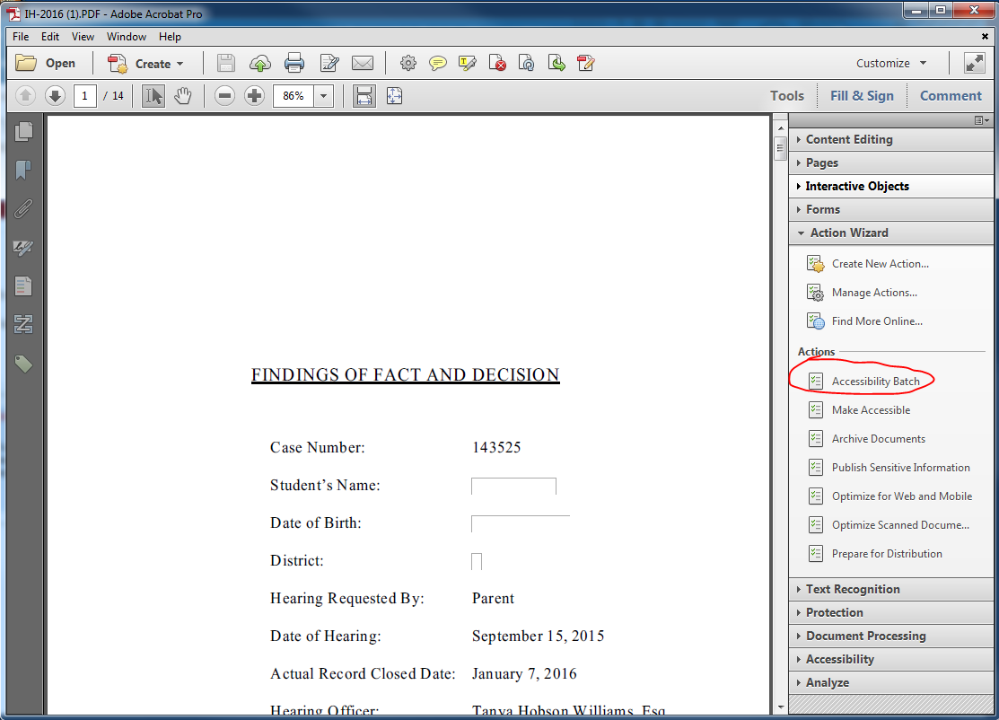

Adding Files and Running the Accessibility Batch Wizard
- Open a PDF file in Adobe Acrobat
- Click Tools > Action Wizard
- Under Actions, click on a new action to run
- Under Files to be processed, click the Add Files icon
- Select files to process. Folders can be selected
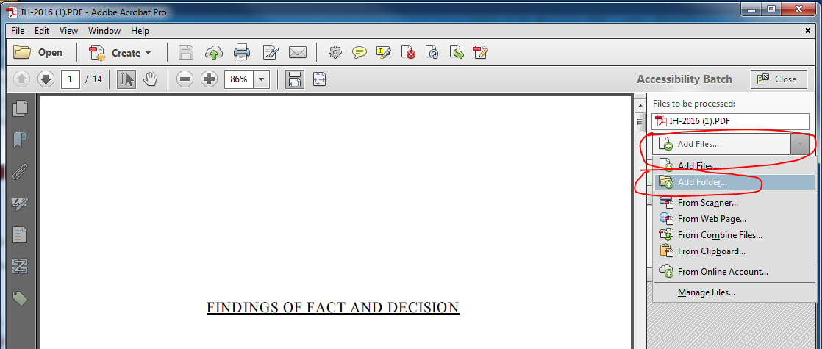

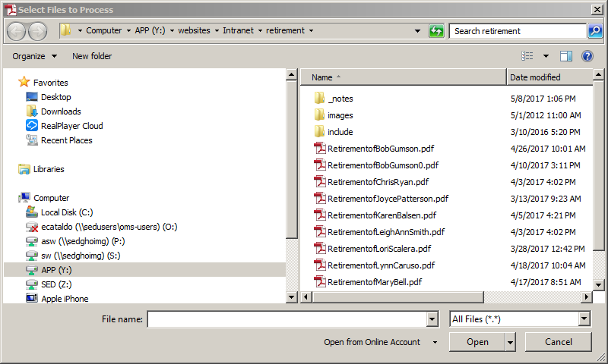
- Once the files are selected click on Start and it will automatically process all of the files:

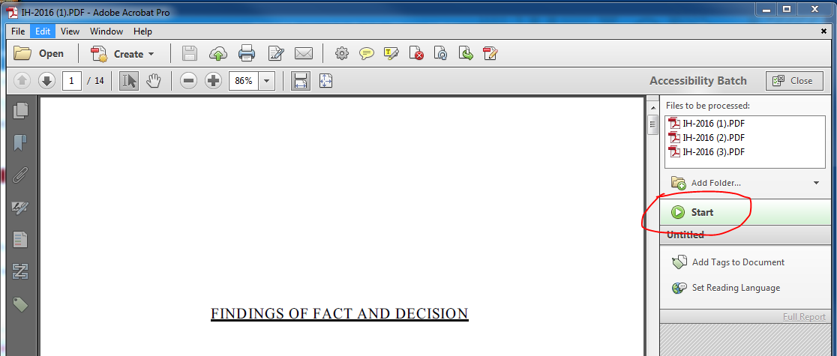

- Once the action is completed and if it worked correctly each file and action will have a green check mark:

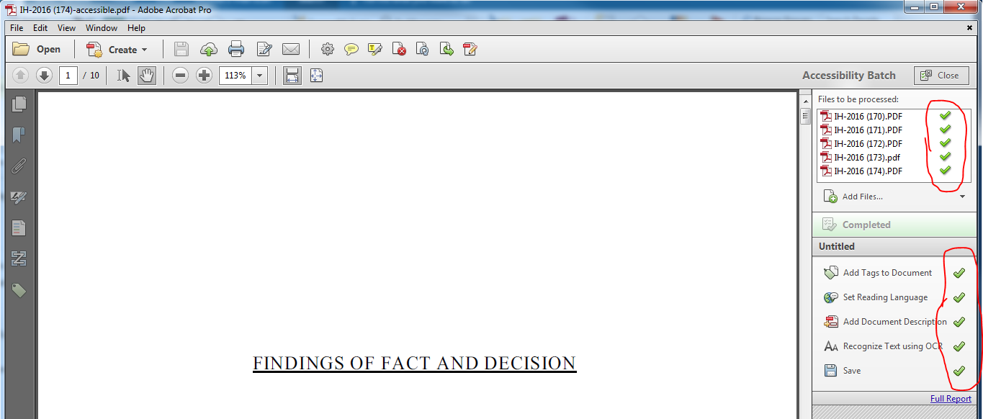

- Although the documents properties are updated by this above process when running the Full Accessibility check this will still often fail.
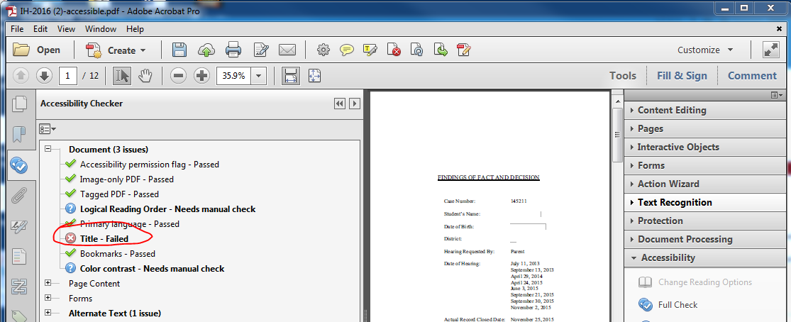

- However, if you right click on the Document-Title you can select “Fix” and then it will recognize the settings (title, subject, keyword and author) that this batch action automatically updated.
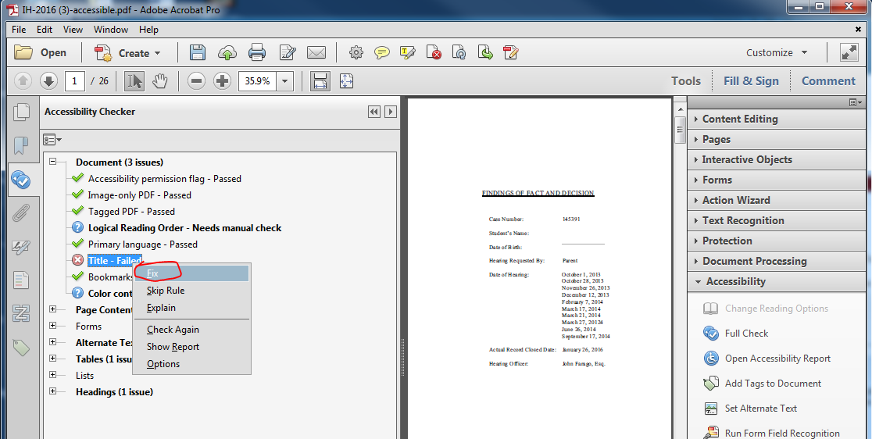

- The action is saved in your local Adobe Acrobat settings and can be modified by right-clicking on the action:

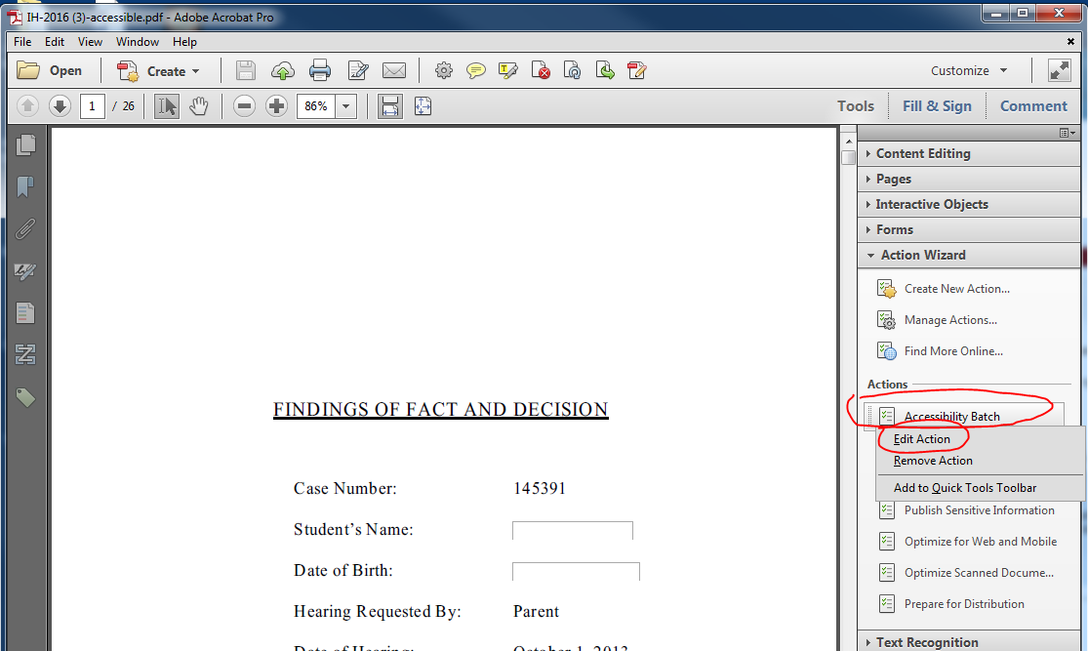

Exporting Batch Wizard Configuration File (*.sequ)
Batch actions can then be exported and imported for other users
- Open a PDF file in Adobe Acrobat
- Click Tools > Action Wizard > Manage Actions
- In the Manage Actions window, under Select an Action, click on batch action (Accessibility Batch)
- Click Export
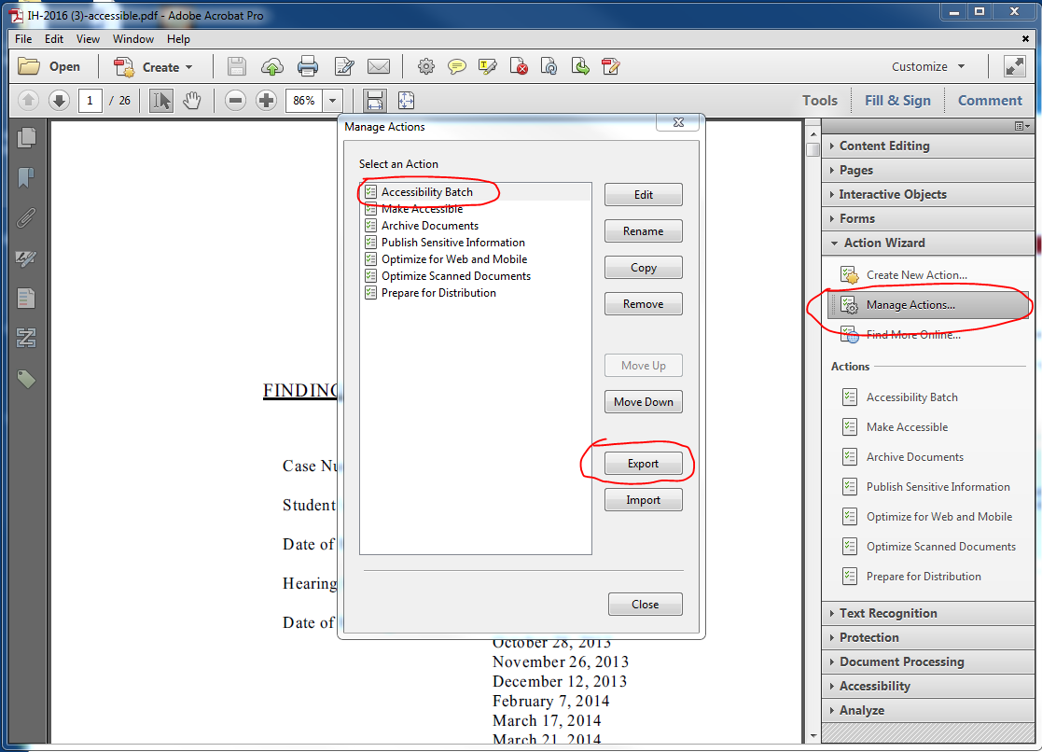

- The file will be saved as *.sequ that can then be shared. All a user needs to do is double-click the file and it will automatically import into Adobe Acrobat.

