Computer Science and Digital Fluency Learning Standards

Implementation Timeline and Roadmap

Overview
The Board of Regents adopted the New York State (NYS) Learning Standards for Computer Science and Digital Fluency in December 2020, the result of a two-year statewide collaborative authoring, reviewing and revision process. Supplemental resources and guidance are available on NYSED’s Computer Science and Digital Fluency Standards webpage.

Roadmap Introduction
The purpose of this New York State K-12 Computer Science and Digital Fluency Learning Standards Implementation Roadmap is to serve as an at-a-glance guide for all stakeholder groups to facilitate attainment of the standards. The NYS Computer Science and Digital Fluency Roadmap and Implementation Timeline has been designed to assist and support districts and educators with the transition to full implementation of the NYS Learning Standards for Computer Science and Digital Fluency. The Roadmap provides a recommended plan spread out over four years. The Roadmap highlights shared goals, objectives, and activities that support key stakeholders with the transition process. Major stakeholders include NYSED, the BOCES, local school districts, institutions of higher education, professional organizations and more.

Based on ongoing needs assessment, districts are encouraged to tailor the recommended implementation activities to meet their specific district level needs during the transition process. Districts may be ahead or behind on various goals within the plan; but all should be moving forward towards full implementation by September 2024. This roadmap is a tool that can be used to facilitate opportunities to engage every student in quality computer science and digital fluency education throughout their school career.

Vision
Every student will know how to live productively and safely in a technology-dominated world. This includes understanding the essential features of digital technologies, why and how they work, and how to communicate and create using these technologies.

Timeline
Phase I: Awareness-Building | Dec. 2020 – June 2022 | Roll-out and building awareness of the new standards and timeline for implementation.
Phase II: Capacity-Building | July 2022 – Aug. 2023 | Focus on curriculum development, resource acquisition, professional development
Phase III: Initial Implementation | Sept. 2023 – Aug. 2024 | All credit-bearing Computer Science courses will be aligned with NYS CS&DF Standards. Continued capacity building.
Phase IV: Full Implementation | Sept. 2024 – ongoing | CS&DF Learning Standards implemented in all grade bands K-12

Goals
Phase I: Awareness-Building | Phase II: Capacity-Building | Phase III: Initial Implementation | Phase IV: Full Implementation
Dec. 2020 – June 2022 | July 2022 – Aug. 2023 | Sept. 2023 – Aug. 2024 | Sept. 2024 - ongoing
Make all education stakeholders aware of the CS&DF Learning Standards and the timeline for implementation. | Provide guidance and support for schools and districts to focus on the integration of the NYS CS&DF Learning Standards into curriculum, instruction, and assessment design; align all credit-bearing Computer Science Courses to the NYS CS&DF Standards. | Support NYS CS&DF Learning Standards implementation in all credit-bearing Computer Science Courses; continue to provide guidance and support for schools and districts to focus on the integration of the Learning Standards into curriculum, instruction, and assessment design for remaining grade bands/courses. | Support the full implementation NYS CS&DF Learning Standards in all grade bands.

Stakeholder Groups
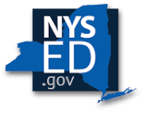New York State Education Department (NYSED); 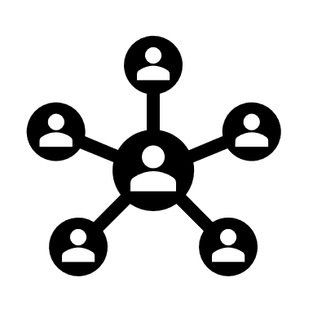Staff/Curriculum Development Network (S/CDN), NYS Model Schools, RICs, BOCES, Big 5;
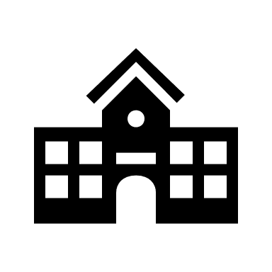districts, schools; 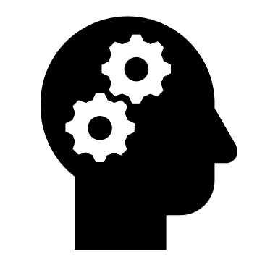 institutions of higher education (IHEs); professional organizations, New York State United Teachers (NYSUT), NYS Teacher Centers, Parent Teacher Association (PTA), and others

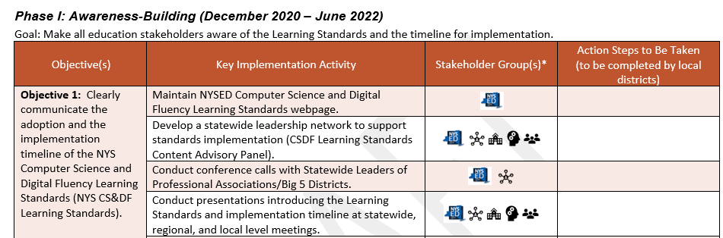
Frequently Asked Questions (FAQs) – before reading the CS&DF Roadmap
How is the Roadmap organized?
The NYSED CS&DF Standards Implementation Roadmap is organized into four phases: Phase I: Awareness Building, Phase II: Capacity Building, Phase III: Initial Implementation and Phase IV: Full Implementation. Each phase has an overarching goal. The Roadmap then breaks down each phase into specific objectives and activities, listed on the left hand side.
The center column recommends which stakeholders will be essential contributors in helping to accomplish each step or action. Please note that there is an icon that includes “Other” which is to be locally determined. This does not preclude local districts from seeking the assistance of other key stakeholders who may not be on this list, or who are not listed for a key activity.
The right-hand column is left purposely open for local planning.
Who is responsible for implementing the Roadmap?
The Roadmap goals, objectives, and activities were designed collaboratively through the development of a Statewide Content Advisory Panel for Computer Science and Digital Fluency. Local school districts, computer science and digital fluency stakeholder groups, P-16 educators, as well as the New York State Education Department, play an important role in implementing the goals, objectives, and activities with actions specific to their locale.
How will we know that we have accomplished the goals and activities in the Roadmap?
The Roadmap “Action Steps Taken” column includes space for each district/school/stakeholder to add in specific local-level action steps that were taken to address the key implementation activities in the Roadmap. This column will vary based on district need. Successful accomplishment of the goals in the Roadmap will be known when administrators, teachers, students, and parents can see, understand, and have a conversation about student learning and expectations aligned to the standards.
Who can assist with this work?
Since the development of curriculum and specific professional development is a local school district responsibility, and based on district and building needs, there will be local decision making in terms of how the goals are accomplished. The NYSED, BOCES Network, New York State Teacher Centers, Regional Bilingual Education Resource Networks, are all available to assist in this work by providing resources and professional development.
Where can districts go to find potential funding opportunities that can be utilized to support implementation activities?
Districts are encouraged to align or reexamine existing resources to target professional development opportunities for teachers as part of district practice. Additionally, districts may browse the New York State Grants Gateway Grant Opportunity Portal an online resource that provides information about grant funding opportunities with State agencies. Additionally, the NYSED Office of Educational Design and Technology has created a Funding Matrix to help administrators compare the features of some funding mechanisms available for educational technology and resources.

Phase I: Awareness-Building (December 2020 – June 2022)
Goal: Make all education stakeholders aware of the Learning Standards and the timeline for implementation.
Objective(s) | Key Implementation Activity | Stakeholder Group(s)* | Action Steps to Be Taken  (to be completed by local districts)
Objective 1: Clearly communicate the adoption and the implementation timeline of the NYS Computer Science and Digital Fluency Learning Standards (NYS CS&DF Learning Standards). | Maintain NYSED Computer Science and Digital Fluency Learning Standards webpage.
 | Develop a statewide leadership network to support standards implementation (CSDF Learning Standards Content Advisory Panel).
 | Conduct conference calls with Statewide Leaders of Professional Associations/Big 5 Districts.
 | Conduct presentations introducing the Learning Standards and implementation timeline at statewide, regional, and local level meetings.
 | Utilize electronic communication and social media to inform stakeholders of the Learning Standards and the implementation timeline.
 | Disseminate talking points and materials for various audiences, including FAQs, ensuring that language is consistent across messengers.

Phase I: Awareness-Building (December 2020 – June 2022), continued
Goal: Make all education stakeholders aware of the Learning Standards and the timeline for implementation.
Objective(s) | Key Implementation Activity | Stakeholder Group(s) | Action Steps to Be Taken  (to be completed by local districts)
Objective 2: Develop K-12 resources to support professional learning aligned to the NYS CS&DF Standards. | Disseminate Department-prepared FAQs (web-based & digital/printable) on updates of NYS CS&DF Learning Standards, regulations that affect CS&DF Learning Standards implementation, state-level grant opportunities, and recommended policies to support attainment of the standards, etc.
 | Develop a professional learning plan to determine the focus of future professional development and major initiatives for effective implementation of the NYS CS&DF Learning Standards.
 | Develop professional learning experiences on the structure and understandings of the NYS CS&DF Learning Standards, including instructional implications.
Objective 3: Develop K-12 guidance to support curriculum and instruction aligned to the NYS CS&DF Standards. | Identify district-level policies, initiatives, Fed/State funding opportunities, resources, and schedules that will support implementation of the NYS CS&DF Learning Standards.
 | Create implementation guides (elementary, middle level, 9-12) with grade-specific examples to support effective implementation of the NYS CS&DF Learning Standards.
 | Communicate the role of various stakeholders to support the NYS CS&DF Learning Standards.

Phase II: Capacity-Building (July 2022 – August 2023)
Goal: Provide guidance and support for schools and districts to focus on the integration of the NYS CS&DF Learning Standards into curriculum, instruction, and assessment design; align all credit-bearing Computer Science Courses to the NYS CS&DF Standards.
Objective(s) | Key Implementation Activity | Stakeholder Group(s) | Action Steps to Be Taken  (to be completed by local districts)
Objective 1: Continue to clearly communicate the adoption and implementation timeline of the NYS CS&DF Learning Standards. | Build, support, and enhance knowledge of the NYS CS&DF Learning Standards in the public sector (including higher education, parents, and the community) to promote effective implementation.
Objective 2: Support local professional learning needs to ensure alignment with the NYS CS&DF Standards. | Establish and/or connect with networks of educators, local, regional, and state organizations, and other stakeholders to collaborate and share professional learning/implementation plans and resources.
 | Partner with interested experts in computer science and digital literacy to feature workshops that enhance the teaching and learning of the NYS CS&DF Learning Standards.
 | Develop and deliver professional learning experiences for school leaders and teachers that builds understanding of how the NYS CS&DF Learning Standards support all students’ ability to live productively and safely in a technology-dominated world.
 | Deliver professional learning on the structure and understandings of the NYS CS&DF Learning Standards, including instructional implications.

Phase II: Capacity-Building (July 2022 – August 2023)
Goal: Provide guidance and support for schools and districts to focus on the integration of the NYS CS&DF Learning Standards into curriculum, instruction, and assessment design; align all credit-bearing Computer Science Courses to the NYS CS&DF Standards.
Objective(s) | Key Implementation Activity | Stakeholder Group(s) | Action Steps to Be Taken  (to be completed by local districts)
Objective 3: Support local school and district needs to integrate the NYS CS&DF Learning Standards into local curriculum. | Analyze current curricular materials, resources, and schedules to determine the changes needed to ensure alignment to the NYS CS&DF Learning Standards.
 | Based on analysis, review, revise, or create curricular units or adopt a curriculum program to ensure alignment to the NYS CS&DF Learning Standards.
 | Coordinate district, local, and regional school collaboration in the design, adaptation, and planning of curriculum aligned to the NYS CS&DF Learning Standards.
 | Pilot and evaluate new/modified curricular units for credit-bearing computer science courses.
 | Ensure that all credit-bearing computer science courses to be taught in the 2023-2024 school year are aligned with NYS CS&DF Learning Standards.
 | Create evaluation frameworks to locally measure the programmatic integration of the NYS CS&DF Learning Standards
Objective 4: Support classroom instructional needs to integrate the NYS CS&DF Learning Standards. | Identify current/new instructional strategies and resources that allow opportunities for students to engage in quality instruction aligned with the NYS CS&DF Learning Standards.
 | Examine current classroom instructional strategies and determine changes needed to ensure classroom instruction is research-based and aligned with the NYS CS&DF Learning Standards.
 | Develop plans and resources to ensure that the instructional needs of all students, including Students with Disabilities and Multilingual Learners, will be met when the NYS CS&DF Learning Standards are implemented.
 | Evaluate current infrastructure capacity, hardware accessibility, and security protocols to effectively support the needs of teaching and learning the NYS CS&DF Learning Standards.

Phase III: Initial Implementation (September 2023 – August 2024)
Goal: Support NYS CS&DF Learning Standards implementation in all credit-bearing Computer Science Courses; continue to provide guidance and support for schools and districts to focus on the integration of the Learning Standards into curriculum, instruction, and assessment design for remaining grade bands/courses.
Objective(s) | Key Implementation Activity | Stakeholder Group(s) | Action Steps to Be Taken  (to be completed by local districts)
Objective 1: Continue to clearly communicate the adoption and implementation timeline of the NYS CS&DF Learning Standards. | Continue to build, support, and enhance knowledge of the NYS CS&DF Learning Standards in the public sector (including higher education, parents, and the community) to promote effective implementation.
Objective 2: Continue to support local professional learning needs to ensure alignment with the NYS CS&DF Learning Standards. | Continue to develop and deliver appropriate professional learning for teachers and leaders that links current research and best practices in instruction aligned to the NYS CS&DF Learning Standards.
 | Continue to develop and deliver embedded professional learning for school leaders and teachers that enhances understanding of the NYS CS&DF Learning Standards with regards to student learning environment, curriculum/program planning, and resources.

Phase III: Initial Implementation (September 2023 – August 2024), continued
Goal: Support NYS CS&DF Learning Standards implementation in all credit-bearing Computer Science Courses; continue to provide guidance and support for schools and districts to focus on the integration of the Learning Standards into curriculum, instruction, and assessment design for remaining grade bands/courses.
Objective(s) | Key Implementation Activity | Stakeholder Group(s) | Action Steps to Be Taken  (to be completed by local districts)
Objective 3: Align and implement instruction and curriculum for all credit-bearing Computer Science courses to the NYS CS&DF Learning Standards at the local level. | Put into practice new/revised local credit-bearing Computer Science courses.
 | Align instructional scaffolds to enable access to the NYS CS&DF Learning Standards for all students including Multilingual Learners and Students with Disabilities.
 | Engage in collaborative planning to ensure all students receive effective standards-based instruction in Computer Science and Digital Fluency.
Objective 4: Gauge and track progress of implementation of NYS CS&DF Learning Standards in all credit-bearing Computer Science courses. | Educators and district leaders discuss and reflect on implementation of local credit-bearing Computer Science courses.
 | Analyze local assessment data to improve implementation efforts and overall student participation and achievement in credit-bearing Computer Science courses.
 | Identify and document district level policies, initiatives, Fed/State funding opportunities, resources and schedules to support implementation.
 | Provide stakeholders with opportunities for feedback and to share ideas, successes, challenges, resources, and outcomes with local districts as well as NYSED.

Phase IV: Full Implementation (September 2024 – ongoing)
Goal: Support NYS CS&DF Learning Standards implementation in all grade bands.
Objective(s) | Key Implementation Activity | Stakeholder Group(s) | Action Steps to Be Taken  (to be completed by local districts)
Objective 1: Implement the NYS CS&DF Learning Standards in all grade bands. | Put into practice new/revised local curriculum aligned to the NYS CS&DF Learning Standards.
 | Align instructional scaffolds to enable access to the NYS CS&DF Learning Standards for all students including Multilingual Learners and Students with Disabilities.
 | Engage in collaborative planning to ensure all students receive effective standards-based instruction in Computer Science and Digital Fluency.
Objective 2: Provide support and structure for educators to gauge and track progress of implementation of NYS CS&DF Learning Standards in all grade bands. | Educators and district leaders discuss and reflect on implementation of NYS CS&DF standards aligned curriculum.
 | Analyze local data to improve implementation efforts and overall student participation and achievement in all grade bands.
 | Identify and document district level policies, initiatives, Fed/State funding opportunities, resources and schedules to strengthen the implementation of the NYS CS&DF Learning Standards in all grade bands.
 | Provide stakeholders with opportunities for feedback and to share ideas, successes, challenges, resources, and outcomes with local districts as well as NYSED.

