**2024-2025 Receivership School Quarterly Report #1**

Report Period: *July 23, 2024, to October 30, 2024 (Due October 30, 2024)*

All sections of this document should be completed by the Superintendent Receiver and/or their designee. State Monitor Districts should streamline reporting, drawing from related metrics, data, target status and applicable evidence as outlined in the most recent Superintendent-District Academic and Financial Summary Status Report based on the Monitor’s Recommendations. Final Reports/Plans should be submitted electronically to [OISR@NYSED.gov](mailto:OISR@NYSED.gov).

Parts I, II, and III of this document are a self-assessment of the *implementation and outcomes of key strategies* related to Receivership and are not considered an evaluation by the New York State Education Department (NYSED). Once this document is finalized, submitted to, and accepted by NYSED, the completed document *must be posted* in a conspicuous location on the district website in applicably dominant languages. All responses should directly align with or be adaptations of previously approved improvement plans and *require explicit verified engagement and input* from Community Engagement Teams.

|  |  |  |  |  |  |  |
| --- | --- | --- | --- | --- | --- | --- |
| School Name | School BEDS Code | District | Lead Partner or EPO | Receivership Cohort | District website hyperlink to this Report | |
|  |  |  |  |  |  | |
| Superintendent | School Principal  (*If appointed since the last reporting period, attach resume*) | School Principal Appointment Date | Additional District Staff working on Program Oversight | Building  Grade-level Configuration | *High Schools Only*  Overall Graduation Rate  (The most recent 4-Year June and August graduation rates) | |
|  |  |  |  |  | June  % | August  % |

|  |
| --- |
| ***Procedural Checklist for Quarterly Report Completion Review***  As the report is completed and reviewed, use the checklist below to confirm completion of each part by placing your initials in the related box. |

|  |  |  |  |  |  |  |  |  |  |  |  |  |  |  |  |  |  |  |  |  |  |
| --- | --- | --- | --- | --- | --- | --- | --- | --- | --- | --- | --- | --- | --- | --- | --- | --- | --- | --- | --- | --- | --- |
| |  | | --- | | ***Title Page*** | | All information is complete with accurate point-in-time information. | | ***Executive Summary*** | | The Executive Summary is completed per the related outline. | | ***Data Trend Tables*** | | All tables have been completed with the most recent point-in-time data. | | ***\*Suspension Tracking and Reporting Addendum*** | | *The *Suspension Tracking and Reporting Addendum* is a process outline  only. No data is entered on this page. | | ***Building- and District-based Commitments and SMART Goal Strategies*** | | The *SMART Goal Strategies and Actions Towards Attaining Commitments*  have been completed by building and district leaders, including, but not  limited to:   * + Incremental goals towards meeting DI targets.   + Strategies, actions, and resources towards meeting DI targets.   + How all goals and strategies will be measured/assessed. | | |  | | --- | | ***Part I - Lead Strategies for School Improvement*** | | Each Lead Strategy is outlined, including how the strategy supports  meeting achievement-based progress towards this year’s DII targets. | | ***Demonstrable Improvement Level 1 Indicators*** | | Each Level 1 Indicator that has been assigned for the current school year  is identified. For each indicator, each bullet point has been fully addressed. | | ***Part III* – *Demonstrable Improvement Level 2 Indicators*** | | Each Level 2 Indicator that has been assigned for the current school year  is identified. For each indicator, each bullet point has been fully addressed. | | ***Part IV* – *Community Engagement Team (CET)*** | | Every prompt is completed and CET implementation meets  *Commissioner’s Regulations §100.11(b).* | | ***Part V- Powers of the Receiver & Part VI – Assurance and Attestation*** | | A clear summary of the application of the Powers of the Receiver is provided.  Required signatures have been obtained from regulatorily approved CET  members who are **not** school administrators. | |

|  |
| --- |
| ***Executive Summary*** |
| Please provide a *plain-language summary* of this Quarterly Report to both reflect the changes and progress made since the last reporting period. Describe the systems and processes utilized to implement lead strategies, engage the community, and actions taken to enact the Powers of the Receiver during the past quarter that have framed a basis for developing a data-informed continuation plan for the academic year.  The summary should be written in terms easily understood by the community-at-large. Please avoid terms and acronyms that are unfamiliar to the public.  Limit the summary to *no more than 500 words*. Applicable links must be made publicly available prior to submitting the report. |
|  |

|  |
| --- |
| ***Overview of School Demographic and Four-Year Trend Data***  *Use the following template to provide demographic and four-year trend data, as applicable. When providing suspension data by category, please refer to the Suspension Tracking and Reporting Addendum on page 6 of this Reporting Document to determine related calculations .*  To ensure the Department frames school-specific targeted Technical Assistance, School Demographic and Year-to-Date Data should be reported as ‘point-in-time.’ |

|  |  |  |
| --- | --- | --- |
| **Data Source:** |  | |
| **Date of Capture:** | |  | |

|  |  |  |
| --- | --- | --- |
|  | **SWD:** | **%** |
| **Total Current Enrollment/Registrant Counts:** | **N =** |  |
|  | **ELL:** | **%** |

**SWDs who are also ELLs:**

**N = / %**

**________________________________________________________________________________________________________________________________________________________**

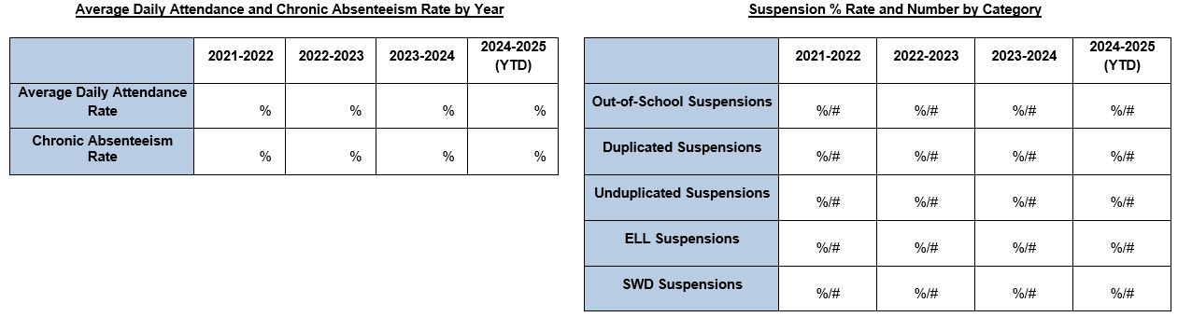

|  |
| --- |
| ***Overview of School Demographic and Four-Year Trend Data***  *Use the template below to provide four-year graduation, drop-out rate, and 3-8 ELA and Math proficiency rates trend data, as applicable.*  Please note that to ensure the Department is able to provide school-specific targeted Technical Assistance, Year-to-Date Data should be reported as ‘point-in-time.’ |

**Graduation Percentage Rates**

**Drop Out Percentage Rates**

|  |
| --- |
| ***Overview of School Demographic and Four-Year Trend Data***  *Use the template below to provide four-year graduation, drop-out rate, and 3-8 ELA and Math proficiency rates trend data, as applicable.*  To ensure the Department frames school-specific targeted Technical Assistance, School Demographic and Year-to-Date Data should be reported as ‘point-in-time.’ |

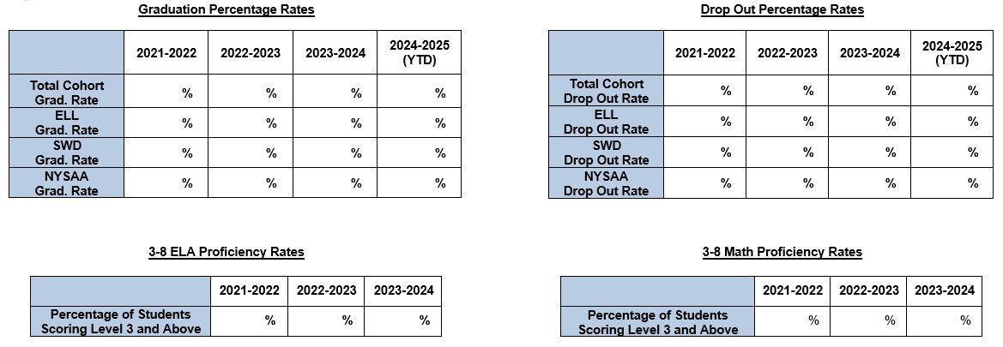

***Suspension Tracking and Reporting Addendum*** *\*The definitions and formulas below are to assist in completing the data tables on page 4. No data should be entered here.\**

**Out of School Suspensions #:***Number of students who received at least one day of out of school suspension.*

$$Out of School Suspension Rate \% =\frac{Number of Students with at Least 1 Day Suspension}{Total Enrollment as of BEDS Day} x 100$$

**Duplicated Suspensions #:** *Number of student(s) suspended out of school more than one time.*

$$Duplicated Suspension Rate \%=\frac{Number of Students Suspended More Than One Time}{Total Number of Suspensions} x 100$$

**Unduplicated Suspensions #:** *Number of students suspended out of school only one time.*

$$Unduplicated Suspension Rate \%=\frac{Number of Students Suspended Out of School Only One Time}{Total Number of Suspensions} x 100$$

**English Language Learners (ELL) Suspensions #:** *Number of ELL students suspended at least one time.*

$$ELL Suspension Rate \%=\frac{Number of ELL Students Suspended at Least One Time}{Total Number of Suspensions} x 100$$

**Students with Disabilities (SWD) Suspensions #:** *Number of students with disabilities suspended at least one time.*

$$SWD Suspension Rate \%=\frac{Number of SWDs Suspended at Least One Time}{Total Number of Suspensions} x 100$$

***Directions for Parts I, II, and III*** - District and school leadership frame a summary of the steps taken to implement lead strategies aligned with Building- and District-based Commitments outlined during the most recent session with OISR, as well as identify key strategies that were included in the 2024-2025 Continuation Plan as part of an ongoing process of *continuous and comprehensive planning and school improvement. Only salient data that maps to DI target attainment should be included.*

The report should include a clear focus on *how evidence guides decisions* and an outline of explicit, equitably accessible educational supports to all students to ensure positive social-emotional well-being and active engagement in learning in an inclusively diverse, culturally relevant, safe learning space. Applicable resources and related guidance can be accessed via the *Department’s Diversity, Equity, and Inclusion* and *Culturally Responsive-Sustaining (CR-S) Education Frameworks*, (@ [DEI Framework and Policy Statement | New York State Education Department (nysed.gov)](http://www.nysed.gov/diversity-equity-inclusion/diversity-equity-and-inclusion-framework-and-policy-statement), [Culturally Responsive-Sustaining Education | New York State Education Department (nysed.gov)](http://www.nysed.gov/crs), and in via the NY Social Emotional Learning Benchmarks @ [NYS SEL Benchmarks (nysed.gov)](https://www.p12.nysed.gov/sss/documents/SELBenchmarks2022.pdf).

* When responding to prompts pertaining to *Quarter 1 Report*, identify processes:
  + Applied throughout Quarter 1to assess the impact of *strategies implemented* to improve student learning outcomes, *as aligned to Building- and District-based Commitments*.
  + Utilized to assess the impact on student learning outcomes that will be newly implemented during the new school year.
* Frame how the implementation of lead strategies addresses *the needs of all learners*, particularly the needs of subgroups of students and those at risk for not meeting State academic standards.
* Claims should be evidentiary in nature.
* Reported information and related data should be accessible and able to be reviewed upon request.

To ensure sustained application of key data where strategy implementation results in *long-term sustainable growth*, District and School Leadership should *assess the impact* of identified lead strategies on student learning, *as aligned to Building- and District-based Commitments* and Technical Assistance and Support sessions and diagnostic review feedback.

Data and narrative outlines should be comprised of supporting documentation. Information, data, and supplements not aligned to key tracking towards target attainment should not be included in this report and may result in the need to amend and resubmit for applicable approval.

|  |
| --- |
| ***Building- and District-based Commitments and SMART Goal Strategies: Specific/Measurable/Achievable/Relevant/Time-bound***  *At the close of the last touch point, the following commitments were identified by school and district leaders as priorities for ongoing school improvement. The SMART strategies section is to be completed by school and district leadership and should include specific, measurable, achievable, relevant, and time-bound (SMART) goals aligned with Lead Strategies and DII targets. Strategies should include incremental assessment of measurable progress and actions toward meeting each commitment and SMART Goal, while also assessing the status of how these commitments and SMART Goals have been aligned with and support meeting DII target attainment.*   * *For example, “ELA proficiency of SWDs will increase 2% by January 2025 and 5% overall by June 2025.”* |

**Building-based Commitments**

**SMART Goal Strategies and Actions Towards Attaining Commitments**

|  |  |
| --- | --- |

**District-based Commitments**

**SMART Goal Strategies, Actions and Resources Towards**

**Supporting Commitment Attainment**

|  |  |
| --- | --- |

|  |
| --- |
| ***Part I- Lead Strategies for School Improvement***  *Include 3-4 core lead strategies that are central to the school’s improvement plan. Such strategies should be a continuation or extension of lead strategies implemented in the prior school year and serve as key levers for improvement based on trends in student performance to serve as overarching approaches for strategically implementing targeted action plans leading to demonstrable improvement.* |

|  |
| --- |
| **Quarter 1 Report - Reflection on Lead Strategies Utilized during**  **July 23, 2024 – October 30, 2024** |

| Identify the lead strategies that guided the school’s improvement strategy during the reporting period, including any that were discontinued and the rationale for doing so. | Status  (R/Y/G) | For each lead strategy, outline how the strategy supported meeting achievement-based progress towards this year’s demonstrable improvement targets. |
| --- | --- | --- |
|  |  |  |
|  |  |  |
|  |  |  |

|  |
| --- |
| ***Part II –* *Demonstrable Improvement Level 1 Indicators***  *List the school’s Level 1 indicators and complete all columns below. This information should provide details about how lead strategies informed the implementation of specific strategies, action steps, goals, and commitments to support progress toward meeting Demonstrable Improvement Indicator targets.* |

|  |
| --- |
| **Quarter 1 Report with Reflection on Lead Strategies Utilized during**  **July 23, 2024 – October 30, 2024** |

| Indicator | Status (R/Y/G) | Identify specific strategies and action steps implemented to support progress for each Demonstrable Improvement Indicator. | * Provide point in time trend data such as BoY, MoY and EoY benchmarks used to measure and track cohorts to determine progress made. Provide evidence of impact and measurable contributive value of specific, applied methods on instruction, student learning, and rates of proficiency in ELA and Math. * Describe how the data trends for this reporting cycle will inform future action steps. * Include a description of any adjustments made to the Continuation Plan and correspondingdata used to inform the adjustment, as applicable. * Provide hyperlinks, inclusive of evidence, such as data, information, and/or related documents. Such must be madepubliclyavailableprior to submitting this report. |
| --- | --- | --- | --- |
|  |  |  |  |
|  |  |  |  |

|  |
| --- |
| ***Part III* – *Demonstrable Improvement Level 2 Indicators***  *List the school’s Level 2 indicators and complete all columns below. This information should provide details about how lead strategies will inform the implementation of specific actions and activities that support goal attainment that support sustainable progress toward Demonstrable Improvement Indicator targets attainment.* |

|  |
| --- |
| **Quarterly Report #1 with Reflection on Lead Strategies Utilized during**  **July 23, 2024 – October 30, 2024** |

| Indicator | Status (R/Y/G) | Identify specific strategies and action steps implemented to support progress for each of the Demonstrable Improvement Indicators. | * Provide point in time trend data such as BoY, MoY and EoY benchmarks used to measure and track cohorts to determine progress made. Provide evidence of impact and measurable contributive value of specific, applied methods on instruction, student learning, and rates of proficiency in ELA and Math. * Describe how the data trends for this reporting cycle will inform future action steps. * Include a description of any adjustments made to the Continuation Plan and correspondingdata used to inform the adjustment, as applicable. * Provide hyperlinks, inclusive of evidence, such as data, information, and/or relevant documents. Such must be madepubliclyavailableprior to submitting this report. |
| --- | --- | --- | --- |
|  |  |  |  |
|  |  |  |  |

|  |
| --- |
| ***Part IV* – *Community Engagement Team (CET)***  [*The Community Engagement Team*](https://govt.westlaw.com/nycrr/Document/I1edd2eef2c3c11e5977b0000845b8d3e?viewType=FullText&originationContext=documenttoc&transitionType=CategoryPageItem&contextData=(sc.Default)) *is a representative body designed to foster and support public engagement. The CET serves as an active thought partner contributing to and supporting the development of recommendations for school improvement as outlined by the school and district.*  *Identify recommendations made by the CET, including how the school community and**community**at****-****large were engaged to (1) provide input into the school’s Continuation Plan and (2) review, update as applicable, and provide a list of CET membership for the 2024-2025 SY.*  *\*Note: Administrative, teacher, and parent representative members of the CET must be selected through the process as established in* [*Commissioner’s Regulations 100.11(b)*](https://govt.westlaw.com/nycrr/Document/I3652de2cc22211ddb29d8bee567fca9f?viewType=FullText&originationContext=documenttoc&transitionType=CategoryPageItem&contextData=(sc.Default))*.* |

|  |
| --- |
| **Report Out of 2024-2025 CET Plan Implementation** |

| * List the constituent categories of stakeholders that have participated as CET members during this reporting period. * Include any changes made to the CET’s membership during this reporting period. Include the role/title of any new members. * Provide data and related evidence used to measure the impact and efficacy of the CET. * Describe how recommendations made by the CET during this reporting period were used to inform the implementation of the school’s improvement plan. | * Outline the process by which new members of the CET will be identified and selected*, including action steps to increase participation of parents/family members and students. * Include any changes that will be made to CET membership for the 2024-2025 school year. Include the roles/titles of new members. * An outline of the school’s plan for CET meeting agenda development, the identification of action items, the role of stakeholders, and how progress will be monitored, and goal attainment measured and reported. * Identify the methods that will ensure the CET will have the necessary information and key data to analyze the impact of lead strategies and/or department-approved intervention and turnaround model in a timely manner. |
| --- | --- |
|  |  |

|  |
| --- |
| ***Part V* – *Powers of the Receiver***  [*NYS Education Law 211-f*](https://www.nysenate.gov/legislation/laws/EDN/211-F) *and* [*Commissioners Regulation §100.19*](https://govt.westlaw.com/nycrr/Document/I1edd2eef2c3c11e5977b0000845b8d3e?viewType=FullText&originationContext=documenttoc&transitionType=CategoryPageItem&contextData=(sc.Default)) *grant certain powers to the School Receiver to be used to manage and operate a school in areas that include, but are not limited to, curriculum, programming, staffing and scheduling.*  *Provide a summary of the use of the School Receiver’s powers during this reporting period. If Powers of the Receiver were not utilized, indicate such.* |
|  |

***Part VI* – *Assurance and Attestation***

By signing below, I attest that the information in this Quarterly Report is true and accurate to the best of my knowledge; and that all requirements with regard to public hearings and Community Engagement Team criteria have been met as necessary and required per Commissioners Regulation §100.19.

Name of Receiver (Print):

Signature of Receiver: ­

Date:

By signing below, I attest that the Community Engagement Team has had the opportunity to provide direct and explicit input into this Quarterly Report and has had the opportunity to review and update, as necessary, its 2024-2025 Community Engagement Team Plan and membership for the current academic year.

Name of CET Representative (Print):

Signature of CET Representative*:

Title of CET Representative:

Date:

***\*The CET Attestation must be signed by a CET member other than a school administrator.***