DCIP Equity Analysis

Directions
The purpose of this document is to ensure that the students in schools identified for the Comprehensive Support and Improvement (CSI), Additional Targeted Support and Improvement (ATSI) and Targeted Support and Improvement (TSI) are given the same opportunities for success as those in schools that are identified as Local Support and Improvement (LSI).
Districts should complete the chart below for each school by first listing the names of the schools in the district in the “School Names” row. Districts with more than 10 schools should complete one table for each Principal Supervisor.
Unless the data for each school is fairly similar, districts will need to address at least one staffing inequity and one enrollment/participation inequity as part of the DCIP. The resulting plan will cover both the actions the district will pursue to reduce the identified data gaps AND the support the district will provide to the schools where there are gaps knowing that these inequities exist. Districts may also opt to address funding inequities by examining their existing student funding formula.
Additionally, the indicators highlighted in YELLOW must be addressed (items 1-4) in the DCIP if there is a significant variation between schools (as outlined under “Notes”).
District Name:

Staffing Inequity Comparison Chart
 | SCHOOL NAMES
 | Support Model | Choose an item. | Choose an item. | Choose an item. | Choose an item. | Choose an item. | Choose an item. | Choose an item. | Choose an item. | Choose an item. | Choose an item.
1 | % of uncertified teachers
2 | Avg # of Teacher Absences
3 | % of teachers w < 3yrs exp
4 | Teacher Turnover
5 | Avg. Yrs Exp of Principal and AP
6 | % of teachers who have been at school 1-2 years
7 | Likelihood of finding substitute teacher coverage for teacher absences* | Choose an item. | Choose an item. | Choose an item. | Choose an item. | Choose an item. | Choose an item. | Choose an item. | Choose an item. | Choose an item. | Choose an item.
8 | Ratio of students per counselor
9 | Ratio of students per social worker
10 | Ratio of students per librarian
11 | Ratio of students per nurse
*for this indicator, select either “high” “medium” or “low” from the drop-down menu
NOTES:
- Districts with inequities related to the following data points MUST have a plan to mitigate the identified inequity for each of the following:
- % of uncertified teachers (must be addressed if one of more identified schools has a rate 20 percentage points higher than a school in LSI)
- Average number of Teacher Absences (must be addressed if one of more identified schools has an average that is five days more than the district average)
- % of teachers with fewer than 3 years’ experience (must be addressed if one of more identified schools has a rate 20 percentage points higher than a school in LSI)
- Teacher Turnover rate (must be addressed if one of more identified schools has a rate 20 percentage points higher than a school in LSI)

- Districts that will be developing a plan around any of the highlighted indicators do not need to complete the remainder of the Staffing Inequity Comparison Chart.
- Districts that do not meet any of the conditions outlined in #1 above will need to select one staffing inequity from any of the others listed to address.

Enrollment/Participation Comparison
 | SCHOOL NAMES
 | Support Model | Choose an item. | Choose an item. | Choose an item. | Choose an item. | Choose an item. | Choose an item. | Choose an item. | Choose an item. | Choose an item. | Choose an item.
1 | % of FRL
2 | % of SWD
3 | % of ELL
4 | Attendance Performance Index
5 | Office Referrals
6 | In-School Suspension Rate*
7 | Out-Of-School Suspension Rate*
8 | % of students in instrumental music programs
9 | Average PTA budget
10 | Average attendance at PTA meetings
11 | Participation rate at Parent Teacher Conferences
12 | % of students attended preschool
13 | % students who speak English at home
14 | % of students who have attended school since entry year (e.g. K, 9th grade, etc.)
15 | % of students who enrolled at the school this year after September
* For suspension rate, use the number of students suspended from school (out-of-school/in-school) at least one full day divided by the number of students enrolled during the school year.
NOTES:
- In recognition that not all of this data may be readily available, districts must complete at least eight rows of this chart. If no inequities are identified after completing eight rows, districts will need to proceed with completing the chart until an inequity has been identified.
- Districts that do not have multiple schools serving the same grade band (e.g. a district with one K-5 school and one 6-12 school) should prioritize the indicators where differences would be of most concern.

Funding Comparison
 | SCHOOL NAMES
 | Support Model | Choose an item. | Choose an item. | Choose an item. | Choose an item. | Choose an item. | Choose an item. | Choose an item. | Choose an item. | Choose an item. | Choose an item.
1 | Per-Pupil Spending

NOTES:
- Edunomics have created a resource that compares performance with funding ACROSS districts and WITHIN a district. Per-Pupil Spending is plotted on the X axis, and Performance Outcomes are plotted on the Y axis, as shown in the diagram below. Districts may find it useful to explore the tools available at https://edunomicslab.org/ny-scatterplots/ to better understand what return on investment looks like through this lens. NYSED would encourage districts to pay attention to any school falling in the bottom right quadrant (Above-Average Spending/Below-Average Outcomes) and consider the programmatic support that may be needed to assist the school.
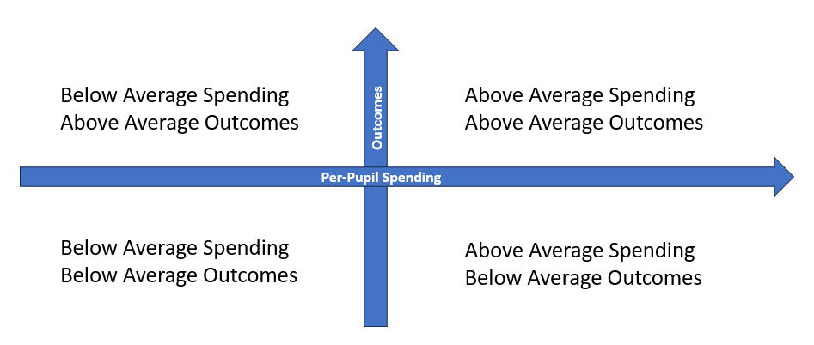
- The Alliance for Resource Equity is a great resource for exploring variations in funding across schools. Their School Funding Blueprint states:
“It's okay for school funding to vary! Variation is not necessarily a bad thing. The question is: Is the variation strategic (aligned with district's goals) and equitable (higher-need schools receive additional dollars)?”
After you have completed the chart above, examine the variations that exist and identify if these are aligned with the district’s goals and are allowing schools with higher needs to receive additional dollars.
If there is any school identified for CSI, ATSI, or TSI that has a per-pupil spending amount significantly lower than the per-pupil amounts of schools identified for LSI, then NYSED would encourage the district to examine its school funding formula to consider ways to ensure more funding is being directed to higher needs schools.

- The Funding Inequity Section of the DCIP should be completed by any district that would like to use Title I, 1003 School Improvement Grant funding to support exploring how to more equitably distribute resources across the district. NYSED encourages districts that have concerns about whether their variations are strategic and equitable, as outlined above, to partner with an organization experienced in supporting districts to re-examine their school funding formula.

The District’s completed Equity Analysis must be submitted with the DCIP.

