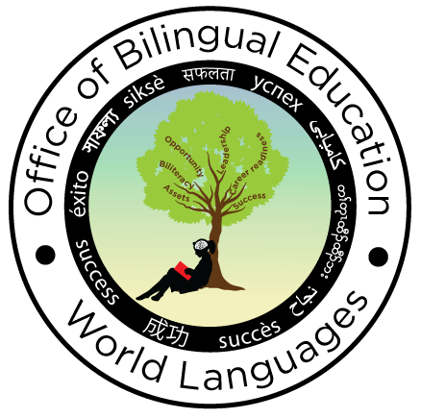
The New York State Seal of Biliteracy
Seal Image Request Form (2019-20)

The Office of Bilingual Education and World Languages will provide the physical Seal sticker to be placed on the diploma and a medallion for each student along with a certificate template. Each school awarding the Seal must submit this online Seal Image Request form by no later than May 31st of each year using the following link:
https://forms.gle/ppxd9gXrVzpUbmm39
In addition, in order to receive the physical Seals, schools must also submit a completed End of Year Data form (as an Excel spreadsheet – do not send a PDF or a link) emailed to obewldocsubmit@nysed.gov.
Physical Seals, medallions and a certificate template will only be provided for students who have completed all of the required criteria at the time the Seals are ordered. If additional students complete the requirements after the deadline (for instance, students who are waiting for AP/IB exam scores that are generally available in July), schools must resubmit amended “School Image Request” and “End of Year Data” forms once the scores are available so that the remaining Seals can be mailed to the contact person.
District name:
School name: |  |  | School BEDS code:
Street address: |  |  | City:
Zip code: |  |  | Request date:
Contact name: |  |  | Date needed by:
Phone: |  |  | Graduation year:
Email: |  |  | Number of students receiving the Seal*:

*The number of students receiving the Seal reported on this form must be only those who, at the time this form is submitted, have met all of the criteria required to earn the Seal (3 points in English + 3 points in a World Language other than English).

Please check the region in which your school is located. | Region | Contact from whom the Seals will be sent (RBERN)
 | Capital-East | Capital District RBERN @ Questar III BOCES
 | Hudson Valley | Hudson Valley RBERN @ SW BOCES
 | Long Island | Long Island RBERN @ Eastern Suffolk BOCES
 | Mid-State | Mid-State RBERN @ OCM BOCES
 | Mid-West | Mid-West RBERN @ Monroe 2 BOCES
 | New York City | Jill Schimmel – NYC DOE
 | West | RBERN West @ Erie 1 BOCES

Superintendent/Chief Administrative Officer or designee electronic signature
By entering your name below, you are signing this form electronically. You agree that your electronic signature is the legal equivalent of your manual signature on this form.

Name: | Title:
Email: | Date:

Submit this online Seal Image Request form by no later than May 31st of each year using the following link:
https://forms.gle/ppxd9gXrVzpUbmm39

Submit the completed End of Year Data form (as an Excel spreadsheet – do not send a PDF) emailed to obewldocsubmit@nysed.gov.

Please allow 1-2 weeks to process your request.

Questions regarding this form can be directed to obewldocsubmit@nysed.gov or via phone at (518) 474-8775.

