ELLs = Current English Language Learners
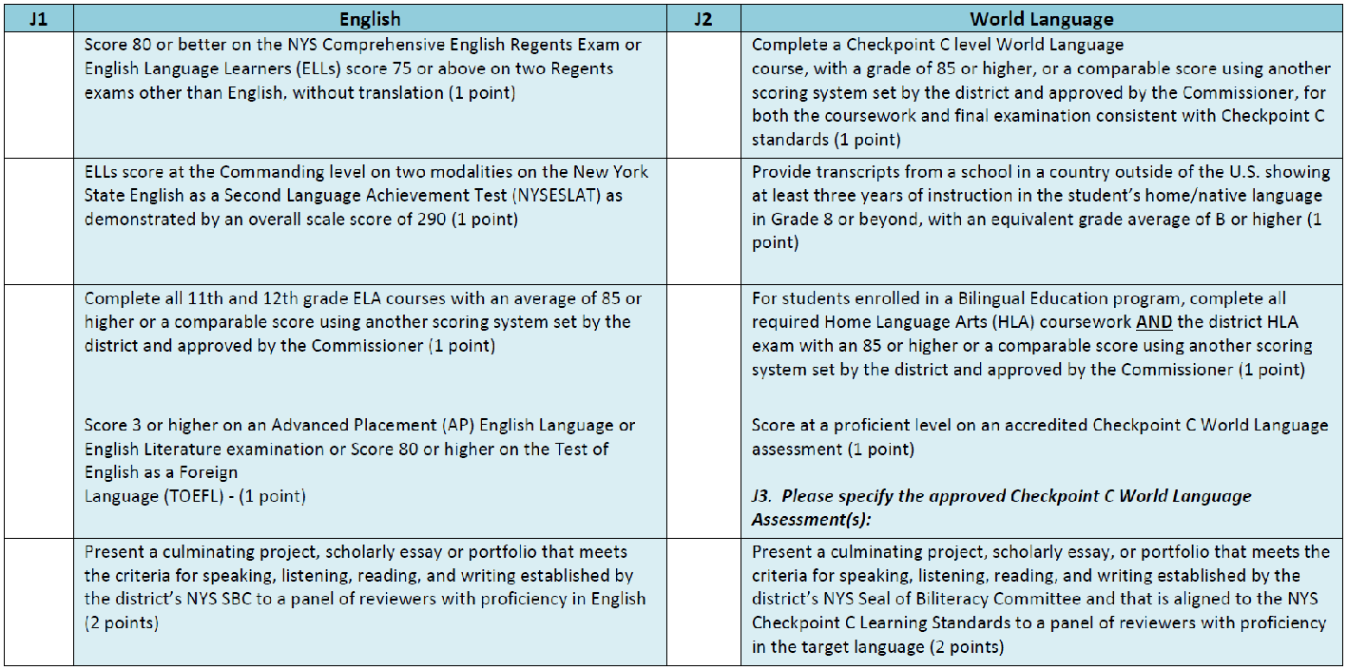

FELLs = Former / Ever English Language Learners

HL = Heritage Learners

WL = World Language Students

