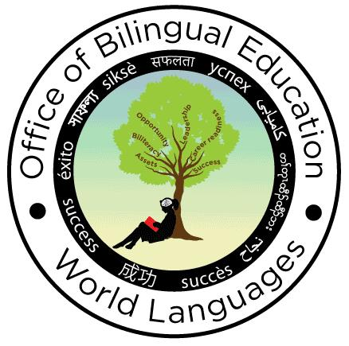
New York State Seal of Biliteracy
District/School Culminating Project Form - 2019-2020

The Office of Bilingual Education and World Languages will be scheduling school visits to sample and observe Seal of Biliteracy Culminating Projects and provide feedback and support to schools. Please provide the date(s), time(s), and location(s) of the Culminating Project presentations as well as the language(s) in which the presentations will be given. This form must be submitted each year the school offers the Seal by no later than April 15th. If your school/district is selected, you will be notified by no later than April 30th with the date/time of visit and the name and contact information of the OBEWL representative that will be present.

If your district has more than one school that offers the Seal and the Culminating Project Presentations will take place at different locations, please submit a separate form for each location. If presentations will take place at the same location on the same dates, only one form need be submitted.

Submit this information electronically using the following link by April 15: https://forms.gle/8nYmjQJmRxZR3cX59

District/School information

District Name:
School Name(s)
Contact Person: |  | Phone:
Email:

Date(s), Time(s), Location and Languages of Culminating Project Presentations

Location of presentations:
Street:
City: |  | County |  | Zip
Contact person at location:  (if different from above) |  |  | Phone:
Email:
Date(s) / time(s) of presentations:
Language(s) of presentations

Superintendent/Chief Administrative Officer or designee electronic signature
By entering your name below, you are signing this form electronically. You agree that your electronic signature is the legal equivalent of your manual signature on this form.

Name: | Title:
Email: | Date:

Submit this information electronically using the following link by no later than April 15: https://forms.gle/8nYmjQJmRxZR3cX59

Questions regarding this form can be directed to obewldocsubmit@nysed.gov or via phone at (518) 474-8775.

