Save the Batch File – Run the Batch File
Batch actions can then be exported and imported for other users
- Open a PDF file in Adobe Acrobat
- Click Tools > Action Wizard > Manage Actions
- In the Manage Actions window, under Select an Action, click on batch action (Accessibility Batch)
- Click Export
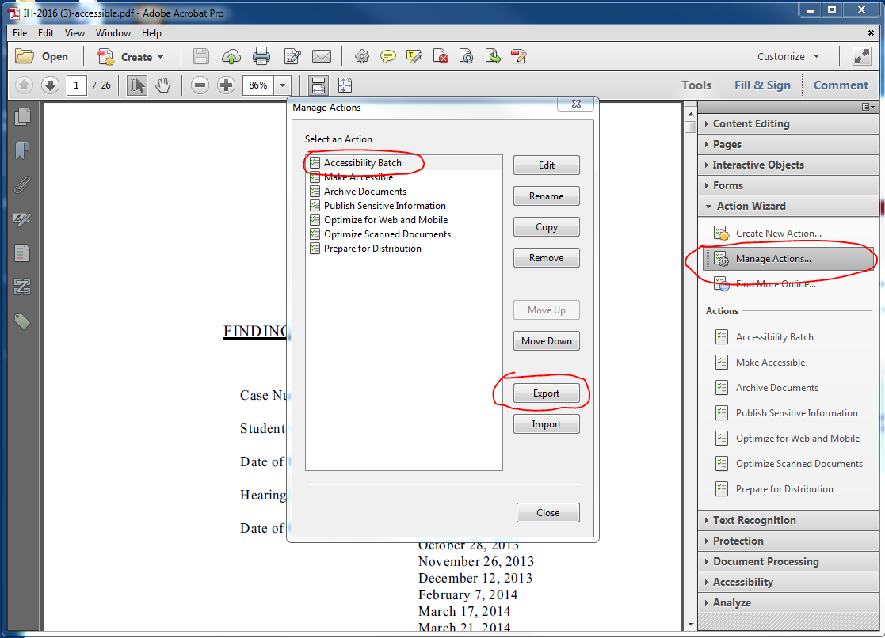

- The file will be saved as a .sequ file, which can then be shared.
