New York State Education Department Office of Early Learning
2019
Prekindergarten Video Training Guide
NYSED Office of Early Learning Video Series: A Guide for Educators Serving Children in Prekindergarten through 2nd Grade
NYSED values play as an instructional strategy in the early childhood classroom. The video series includes examples of purposeful, play-based instructional strategies that assist children in developing critical foundational skills. In the early grades, it is particularly important for educators to recognize and balance individual and group needs, active and quiet times, teacher-directed and child-selected activities, and English and home language development. Teachers influence what and how children learn by creating an environment that reflects developmentally, culturally, and linguistically appropriate practices and instruction. Intentional planning provides a framework for learning that is culturally and linguistically responsive, playful, interactive, and interdisciplinary.

Training Overview
These video companion documents are included to support session facilitators in engaging participants in rich conversations about prekindergarten. They are intended to guide participants through activities that will support educators and administrators in understanding developmentally appropriate learning environments and instruction for young children.

Facilitators: Use these documents in a way that will best fit your audience. Facilitators are encouraged to add activities or change the format of any of the activities provided. There are two videos in the prekindergarten series. Facilitators can use both videos in a single session or break the trainings into several days. As presented in this document, it is intended that the entire professional learning will constitute five hours of training.

Prior to watching the Prekindergarten Environment Video

Activity One: Environmental Messages (page 4)
As participants join the session, they are invited to review the Environmental Messages handout. This handout encourages participants to think about their classroom set up, and the messages it conveys to students. Participants complete the chart to reflect how their current set-up conveys these messages.

Facilitator Note: Participants can draw a quick sketch of the classroom. This map can be used during discussions of classroom set-up and planning for learning center locations.

After watching the Prekindergarten Environment Video

Activity Two: Center Checklist
Participants complete the Center Checklist based on their classroom environment by reviewing each center area on the checklist and selecting all boxes that are currently present in the classroom. Participants identify centers they would like to improve or add to their classroom and note the specific changes they want to make to those areas. Then, think about and note how improvements can be made to classroom learning centers. This may be making a time sensitive goal, along with noting what materials may be needed to meet this goal.
Facilitator note: This activity can be completed individually or in small groups. Participants can choose one or two centers from the checklists to work on at a time. If the training occurs over several days, it may be helpful to have participants take these checklists back to their classrooms to complete and bring back to the following session. It is important to have a share out or discussion session after completing this activity.
Facilitators may want to review portions of the Environment Video during whole group discussion.

Activity Three: Environmental Priorities
Participants should use the information from the Center Checklist Activity to guide their thoughts toward formulating achievable goals for the classroom environment. Once complete, discuss in partnerships or small groups and share out. The Environmental Priorities form can be used for discussions with administrators or teacher leaders to determine priorities for the classroom environment and any needed support.

Facilitator Note: If participants are working in teams, such as grade level teams, this exercise can be extended to make a grade level priority list.

Activity Four: Play as an Instructional Strategy
This activity should be used as an introduction to the Prekindergarten Instructional Video. Participants should begin to develop their own definition of play as an instructional strategy. Prior to viewing the video participants begin to brainstorm ideas about the use of play in the classroom.

Facilitator Note: This activity can be referenced throughout the training. As participants watch the instructional video, they should be encouraged to take notes and develop their definition of play as an instructional strategy further.

Activity Five: Learning Standards Highlights
Participants should view the Prekindergarten Instructional Video prior to completing this activity. Facilitators are encouraged to use the supplemental resource, New York State Prekindergarten Learning Standards: A Resource for School Success, during the discussion of standards and how they influence instruction.

Facilitator Note: It is helpful for participants to be familiar with the New York State Prekindergarten Learning Standards: A Resource for School Success. Consider adding a session on reviewing the standards if necessary.

Activity Six: Thematic Planning
Use the planning tool to begin brainstorming ideas around a specific topic or unit of study that you currently use in the classroom. Choose one center to develop ideas for activities or materials that connect with the unit of study.

Facilitator Note: This activity can be done individually or in teams. It will be helpful to provide a copy of the TIP SHEETS for participants to reference while completing this activity, Tip Sheets for Practice and Play. Time constraints will determine how many center areas can be developed. Encourage participants to reference supplemental materials during this activity, which may include the NYS Early Learning Standards, curriculum materials, topic maps, etc.

Activity Seven: Questioning Strategies to Enhance Learning
Participants should use the Teacher Questioning Chart to facilitate conversations about the teacher’s use of questioning techniques in the classroom. Participants should use their previous notes and activities to guide discussions about how questions can be used in learning areas, and during instruction to encourage children to think deeper. Based on the topic from Activity Six: Thematic Planning, choose one classroom area to develop a list of specific questions, using Bloom’s areas as a guide.

Facilitator Note: This activity can be expanded into making cue card rings or signs to be placed throughout the classroom for teachers to reference when working with students as a quick guide to the types of questions that can be asked to enhance learning.

Environmental Messages (Activity One)
Using the checklist below, consider what message your classroom currently portrays to children. Self-reflect and check the boxes below for all that apply in your current classroom. Discuss. Complete the “How is this message conveyed?” column.

Classrooms should allow children to feel that: | How is this message conveyed?
- This is a safe and comfortable place.

- I belong here and I am valued.

- I can make friends and share.

- I know what I am expected to do.

- I can do interesting work here.

- I can find what I need and put things back where they belong.

- I can make choices.

- I am challenged to try new things.

- I can use and share all my languages.

As a group, discuss the following question: What environmental message is portrayed to children in my classroom right now?

Center Checklist (Activity Two)
Choose a center below and complete the checklist.

 | Blocks and Building Center
- A location away from foot traffic, with enough space for building substantial structures | - Shelving to hold sets of several different types of blocks and building materials (e.g., wooden blocks, connecting blocks, foam unit blocks, multiple shapes of blocks) | - Props, materials, and accessories that extend block and building play and reflect students’ diversity (e.g., figurines, vehicles, road signs, ramps)
- Selections of books and texts representative of the students’ languages about building and landscapes; rotated to link to specific themes and/or learning goals | - Art and craft materials and supplies for children to plan and create additional structures and accessories
Goal(s):
Materials needed:
 | Creative Arts Center
- Dedicated space near a clean-up area | - Multiple work surfaces for individuals and groups (e.g., tables, easels, floor areas) | - Audio station for listening to different styles of music
- Three-dimensional and tactile objects for sensory exploration and experimentation (e.g., beads, string, modeling clay, rocks, pinecones) | - Props to extend book experiences, such as flannel boards and pieces, puppets, to recreate stories or represent experiences | - Illustrated books and sample artwork, at children’s level, organized by theme or genre and inclusive of diverse cultures and art forms
- Displays of children’s artwork and storage for ongoing projects | - Materials for creating instruments (e.g., boxes, rubber bands, strings) | - Musical props and instruments for exploring dance, music, and sound
- Variety of drawing, painting, and natural materials for exploring color, form, and texture (e.g., brushes, straws, paint, different sizes of paper)
Goal(s):
Materials needed:

 | Dramatic Play Center
- Space for up to four children in a noisy area of the room | - Play props and materials that promote dramatic play and role playing (e.g., office equipment, workshop items, puppets, cash register, pretend money, stuffed animals etc.) | - Multiple text types, including narrative, informational, and other kinds of texts; books with diverse characters and topics; and books at varying levels
- Play equipment and furniture that can be moved and converted (e.g., table and chairs, shelving, kitchen, safety mirror, benches, storage bins etc.) | - Props to extend book experiences, such as flannel boards and pieces, puppets, and other story character figurines to recreate stories or represent experiences | - Authentic props and materials (e.g., calculators, writing materials, clipboards, arts/craft materials for making signs and props, coupons, newspapers, etc.)
- Variety of props for dramatic expression that reflect diversity in gender, culture, and occupations
Goal(s):
Materials needed:
 | Literacy Center
- A quiet, comfortable, cozy area of the classroom | - Books in multiple formats (e.g., listening on CD, digital books, interactive books) | - Props to extend book experiences, such as flannel boards and pieces, puppets, and other story character figurines
- Books and texts (about 20) that are on display, forward facing and rotated often according to current interests, topic, and/or theme | - Word wall depicting topic/theme-base words; common words and rare words with illustrations or depictions | - Computers/devices with developmentally appropriate games and activities linked to learning goals; scheduled to ensure equity
- Multiple text types, including narrative, informational, and other kinds of texts; books with diverse characters and topics; and books at varying levels | - Writing materials with pencils, markers, crayons, and pens, and materials to write on and book making materials; alphabet and numeral strips and stamps | - Books and texts (about 20) that are on display, forward facing and rotated often according to current interests, topic, and/or theme, and relevant to the cultures and languages represented by the children in the classroom.
- Additional books in labeled bins, at children’s level, organized by theme or genre, and representative of the children’s languages
Goals(s):
Materials needed:
 | Writing Center
- A table and chairs to accommodate at least two children | - Upper case and lower-case alphabet stamps and ink pads | - Variety of sizes of paper to include lined and unlined paper
- Variety of writing implements to include markers, crayons, colored pencils, elementary pencils, and regular pencils | - Word wall depicting topic/theme-base words; common words and rare words with illustrations or depictions | - Environmental print such as fronts of cereal boxes or snack boxes that are gathered in a book for students to use
- A variety of ABC books that allow children to expand vocabulary in English and their home languages while identifying upper- and lower-case letters | - Materials for making simple books including a stapler or paper fasteners | - Letter tiles or magnetic letters for sorting letters
- Word strips with a picture and a word that coincide with the current or previous themes bound together for children to use as a sample | - Clipboards with paper and pencils attached or white boards with dry erase markers and an eraser so children can take the clipboards to write around the room
Goals(s):
Materials needed:

 | Math and Manipulatives Center
- Workspaces for children to work with materials, including tables and floor areas | - Shelves to hold sets of several different types of objects, sorting bins, graph paper, materials for making patterns | - Selections of books and texts that feature counting, themes with shape patterns, comparisons, and representative of the children’s languages.
- Posted math visual aids such as number lines (including flat number lines), number lists and representations, calendars, simple graphs, height measurement stick, etc. | - Games and activities: games that rely on counting, puzzles, pattern games, games with dice or number spinners, matching games, math computer games and apps | - Manipulatives such as pegs, sorting materials, Cuisenaire rods, nesting and linking cubes, shape patterns, counting beads, measuring tools, scales etc.
Goal(s):
Materials needed:

 | Science and Discovery Center
- A location near sunlight for growing plants | - Paper and writing materials to draw or record observations | - Selections of games and puzzles that are related to science areas, such as healthy bodies, animals, weather, living things, space, movement, etc.
- Workspaces and tables for individuals and groups to conduct experiments and make observations (e.g., wall space, tables, floor areas) | - Selections of books and texts representative of the children’s languages about science; rotated to link to specific themes and/or learning goals (e.g., earth and space, living things, physical properties) | - Displays and collections of natural objects (e.g., rocks, leaves, sand, dirt, roots) and depictions of science-related topics (e.g., posters, models, graphics, digital displays, videos)
- Variety of tools and materials for using senses, observing, and experimenting (e.g., natural materials, magnifiers, art supplies for recording, measuring devices, trays, droppers etc.)
Goal(s):
Materials needed:
 | Sensory Center
- Dedicated space near a clean-up area | - Table or area specifically designed for sand, water, or other sensory play | - Smocks to protect clothing from getting wet in the water table
- Props to extend play and talk in the sand table such as small figurines, cars and trucks, scoops, buckets, paper with scissors for cutting | - Mop, broom, and dustpan for cleaning up spills | - Props to extend play and talk in the water table such as small water droppers or basters, sink and float materials, or adding colors to the water
- Interesting materials that are rotated to provide a variety of sensory and language experiences such as hay, dirt/mud, sticks, rye, pretend or real grass, oobleck (cornstarch and water), bubbles, or finger paint
Goal(s):
Materials needed:

My Priorities for My Classroom Environment (Activity Three)
Determine priorities for the ______________ school year. The overall environmental goal is:
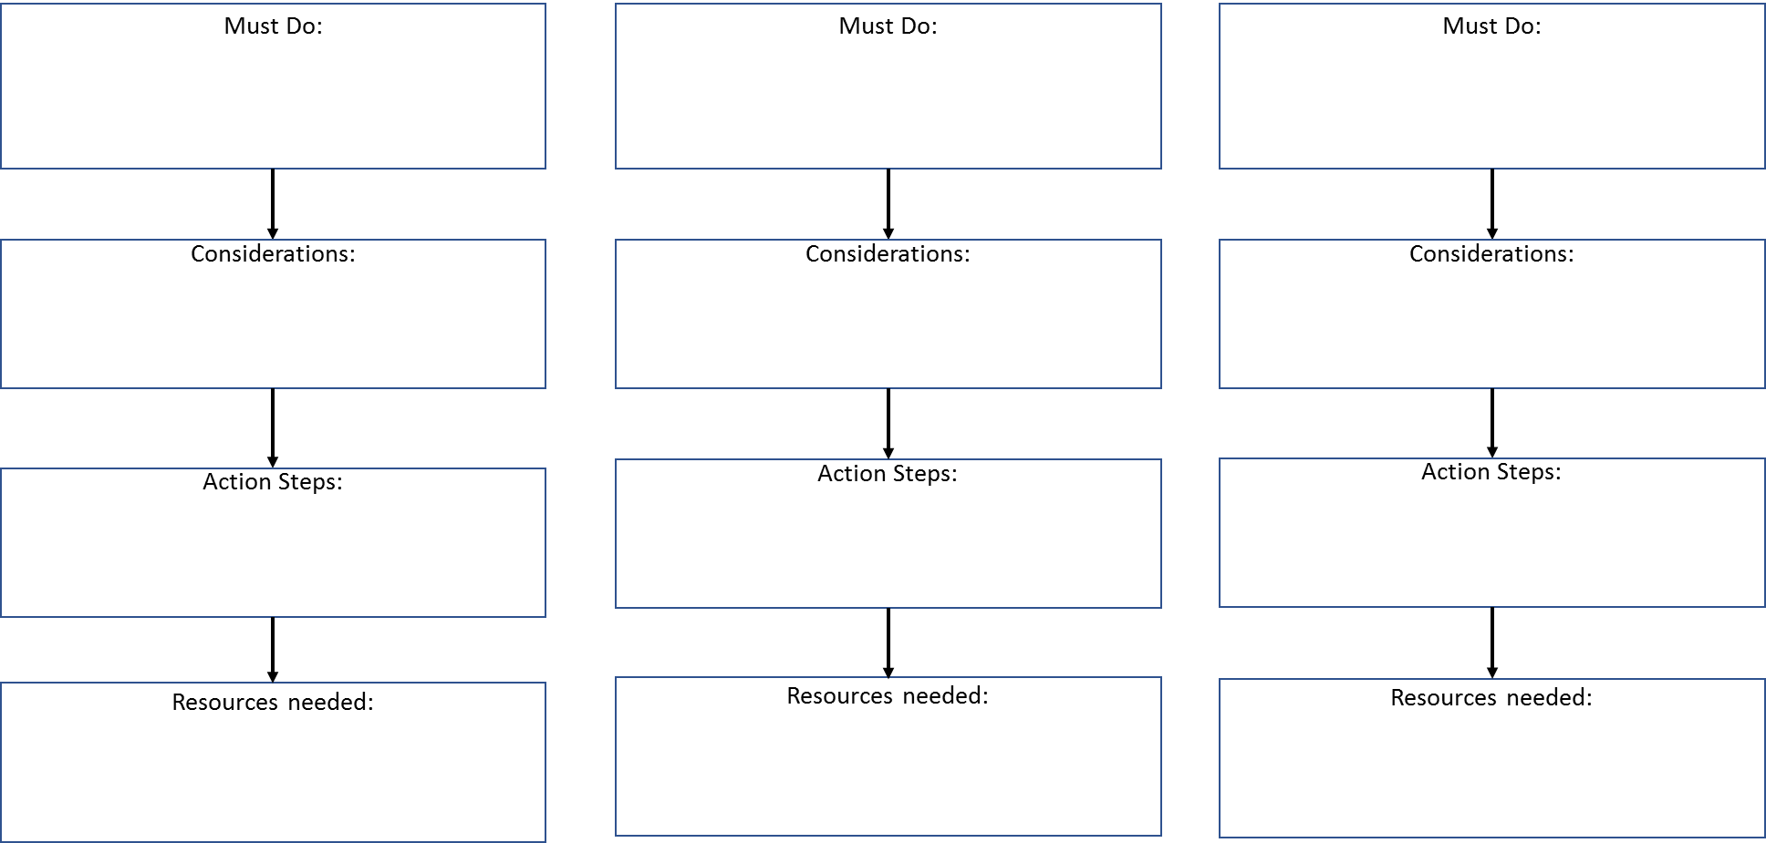
Defining Play as an Instructional Strategy (Activity Four)

Prior to watching the instructional video, brainstorm thoughts and ideas to the questions below.

Question | Recess / Unstructured  Play | Play as an Instructional Strategy
What does this look like? Indoors? Outdoors?
What is the role of the teacher?
What is the role of the child?

Defining Play as an instructional strategy:

Instruction: Highlights
Approaches and strategies used to teach content so students can learn; the “how” | Act of teaching to meet students where they are; outlines by curricula and guided by what is understood about individual students | Utilizes learning environments, interacting with students/connection, creating a classroom culture, fostering student engagement, embedding social/emotional and home language supports
Hands-on practice and purposeful *PLAY* are vital instructional strategies for students to understand abstract concepts, hone skills, and for teachers to observe student learning and social interaction | Grounded in Child Development Theory and Developmentally Appropriate Practice | Ongoing, cyclical, and intrinsically linked to formal and informal assessment
Learning Standards and Instruction (Activity Five)
Use the highlights below to guide your turn and talk discussion.
NYSED Learning Standards: Highlights
- The “where are we going” or destination
- Articulate a learning progression along a continuum
- Provide a framework for local planning and development
- NOT designing as a lockstep progression of lessons or curricula since children’s pace of development is not uniform
.

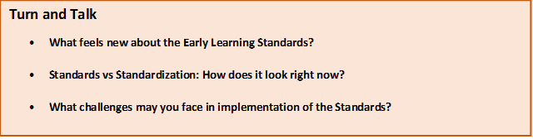
Thematic Planning (Activity Six)
Use the Unit Overview to begin planning activities for learning centers.

- Unit Overview

Unit Topic
Names the topic on which the unit of study focuses.

Essential Question
An essential question is an authentic, child-friendly question that connects the knowledge and skills that children should develop throughout the unit. Essential questions are ‘big’ questions for which there is no single answer.

Focus Questions
Focus questions represent the major inquiries of the unit. They build over time and require children to make connections across all content areas.

Student Outcomes
Student outcomes are the learning targets for children. What are children able to do as a result of instruction?

Academic Vocabulary
Academic vocabulary words help children understand the unit focus questions and access complex texts. These words can be supplemented by vocabulary in read alouds.

Foundational and Supporting Texts
Foundational and supporting texts include a combination of literacy and informational texts that can be read throughout the unit. Foundational texts help students interpret and answer the essential/focus question(s), and supporting texts support students’ understanding of essential/focus questions while also supporting learning centers and the needs/interests of individual students.

Family and Community Engagement
Opportunities for inviting families to share their experiences and knowledge with the class, or for extending learning outside of the classroom.

Culminating Celebration
A culminating celebration is an opportunity to reflect on the unit with the children, as well as to note and celebrate the growth and learning that has occurred.

Learning Center Planning Page
 | Week 1 | Week 2
Blocks
Learning Center
Math and Manipulatives Learning Center
Dramatic Play Learning Center
Creative Arts Learning Center
Literacy and Writing
Learning Center
Science and Nature
Learning Center
Learning Center Planning Page (continued)
Week 3 | Week 4
Blocks
Learning Center
 |  | Math and Manipulatives Learning Center
 |  | Dramatic Play Learning Center
 |  | Creative Arts Learning Center
Literacy and Writing
Learning Center
Science and Nature
Learning Center

Teacher Questioning Chart (Activity Seven)

Bloom, B.S. (1969). Taxonomy of Educational Objectives: The Classification of Educational Goals. United Kingdom: Longman Group

Supplemental Material
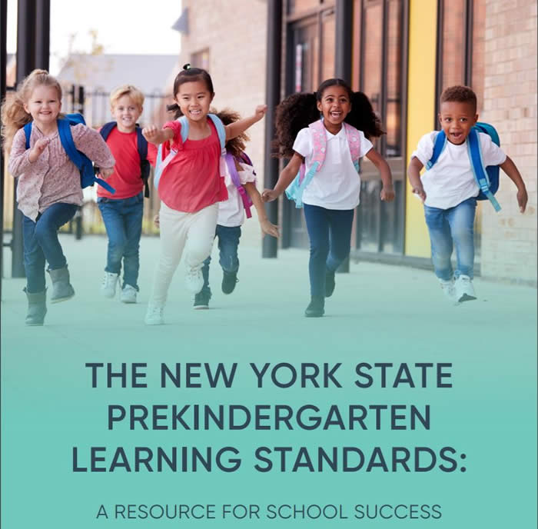
Resource Guides for School Success: The Prekindergarten Early Learning Standards

New York State Office of Early Learning Guidance

- Emergent Multilingual Learners in Prekindergarten Programs Guidance

- A Resource to Special Education Support Services – From Birth to Third Grade

- Planning for High Quality Prekindergarten Programs Guidance

- Tip Sheets for Practice and Play: Guidance for Learning Centers

