WORK-BASED LEARNING (WBL)

TRAINING PLAN

The work-based learning (WBL) training plan documents the necessary components of a successful work-based learning experience. An effective training plan outlines all components of a WBL experience and clarifies the expectations for student learning. It is important for the WBL coordinator, the employer/mentor, and student to work together to decide on the responsibilities, tasks, and/or projects that will best support the achievement of these expectations. For example, if a training plan includes the attainment of certain technical skills, student assignments should include the opportunity to acquire and practice them during the experience.

The training plan should be personalized for the student and the work placement. A WBL experience should build on a student’s prior skills to meet state and industry standards. A well-developed training plan weaves together standards, the student's previous experience, and worksite assignments to develop a personalized set of learning expectations.

The training plan provides a structured framework through which a student’s learning outcomes may be measured.

Importance of Training Plan During Unexpected Events
The training plan becomes more important in times of unexpected interruptions in WBL due to external events. The extended school closures in the spring of 2020 caused by the COVID-19 pandemic highlighted the difficulty in meeting state-required hours when schools and/or businesses were closed. In the case of an unexpected interruption, WBL coordinators should follow the training plan to determine which high-quality, successful WBL experiences can be modified to be delivered remotely. When circumstances necessitate the utilization of remote or virtual WBL experiences, the plan may involve multiple employers/mentors, placements, and remote or virtual experiences to meet expectations. If remote or virtual WBL opportunities are unavailable, WBL coordinators can also work with teachers, administrators, and industry partners to provide experiences that would help achieve the goals of the training plan through experiences such as school-based enterprises, community-based projects, or industry partner-led digital projects.

Procedure
WBL Training Plan Content
Placement Information
- Student
- WBL Coordinator
- Type of Experience
- Employer/Mentor
- Placement
- Work Description
Student Background
- Related Instruction
- Courses Completed
- Career Goal
- Skills and Talents
- Accommodations
Personal Objectives
- Academic Enrichment
- Career Development
- Personal Development
Learning Expectations
- Work-Related Skills
- Technical Skills
Evaluation
- Work-Related Skills
- Technical Skills
- Rating Scale for Measuring Achievement Levels
- Hours Completed
Signatures
The WBL coordinator assumes primary responsibility for the development of a personalized training plan for the student. The coordinator will work with other appropriate school personnel to develop the training plan, including, where applicable, CTE teachers, ELL teachers, and IEP service providers. The WBL coordinator, in conjunction with other appropriate staff, identifies learning experiences that should be provided for the student in the classroom or on the job. This plan should be carefully created as students, for liability reasons, should not be performing tasks that are not specifically outlined in the training plan.

The employer/mentor (the student’s immediate supervisor) is then asked to assist the WBL coordinator by
- identifying skills for which training can be provided at the workplace using the training plan,
- adding responsibilities, tasks, and/or projects to the training plan that are unique to the workplace,
- supervising the student’s training for specific job skills, and
- assessing the student’s strengths and weaknesses in completing tasks at the workplace.

The WBL coordinator finalizes the training plan after consultation with the employer/mentor and then reviews the plan with the student to make sure the student understands the expectations. The WBL coordinator will also prepare the student for an initial meeting with the employer/mentor before the start of the experience.

The WBL coordinator visits the workplace periodically (or communicates with the employer/mentor if site visits are not possible) to discuss the student’s progress toward meeting the expectations set out in the training plan. Advice from the employer/mentor is used to make modifications in the student's experience and to determine what related instruction would further student success in the WBL placement.

The training plan and related evaluation documents should be retained as student records of work-based learning.

Content of Training Plan
WBL coordinators may utilize the training plan template found and allow customization based on student learning needs. At a minimum, an effective training plan includes the following elements.

Placement Information
The plan identifies the student and the name of the employer/mentor. Information should also include the name of the organization, contact information, and the location where experience will be conducted. This section also describes the important time considerations. When does experience begin and end? What is the established schedule? How many hours will the student be working per day, per week? The type of WBL experience should be identified using one of the New York State Education Department registered titles or as an unregistered experience. A list of unregistered WBL experiences can be found on the NYSED CTE Work-Based Learning Unregistered Experiences webpage. Finally, a brief description of the work, including specific duties, responsibilities, specific assignments within scope of practice/program, or projects in which the student will be engaged must be included.

Student Background
WBL is a partnership in learning among student, employer/mentor, and school staff. Successful experiences happen when all parties benefit. Students benefit most when they are able to find meaningful connections between a planned experience and other academic content. When a student intentionally evaluates the ways previous courses and concurrent related instruction connect to work-based learning, classroom and on-site learning experiences reinforce one another.

Students are not blank slates arriving at the worksite. Each has unique aspirations and talents. Employer/mentors can best support student learning by providing job assignments which align with students' career goals or, in the case of undecided goals, expose students to possibilities. Additionally, students have skills developed from previous learning experiences, which could be valuable to work site tasks. For example, a student might be fluent in a second language, which might be an asset to the employer/mentor. It would also be beneficial for the student and employer/mentor to discuss career goals and the student’s skills and talents at their initial meeting.

Also, some students might require an accommodation that is essential for the employer/mentor to consider. If the student has a disability that requires accommodation (either under section 504 of the U.S. Rehabilitation Act or Individuals with Disabilities Education Act) the WBL coordinator must provide information to work sites on compliance with federal non-discrimination statutes and accommodation strategies. Students who are English Language Learners (ELL) also might require accommodations and this should be noted in the plan.

Personal Objectives
This section of the plan is an opportunity for students to express why they are participating in a WBL experience. Intentionally assessing how personal objectives relate to academic enrichment, career exploration, and personal development provide students with a chance to consider why the learning experience will support their growth. Objectives do not need to be extensive, but students should be able to summarize their goals in undertaking WBL. This can serve as foundation upon which an employer/mentor can build experiences that meet the student’s needs.

Learning Expectations
Learning expectations are the heart of the training plan and describe what the student is expected to learn and be able to do. Work-related skills are the personal skills, aptitudes, and abilities that can be applied at any workplace and technical skills are the skills that are specific to a career area. WBL expectations can be drawn from appropriate standards and resources, some of which may already be in use and are detailed below.
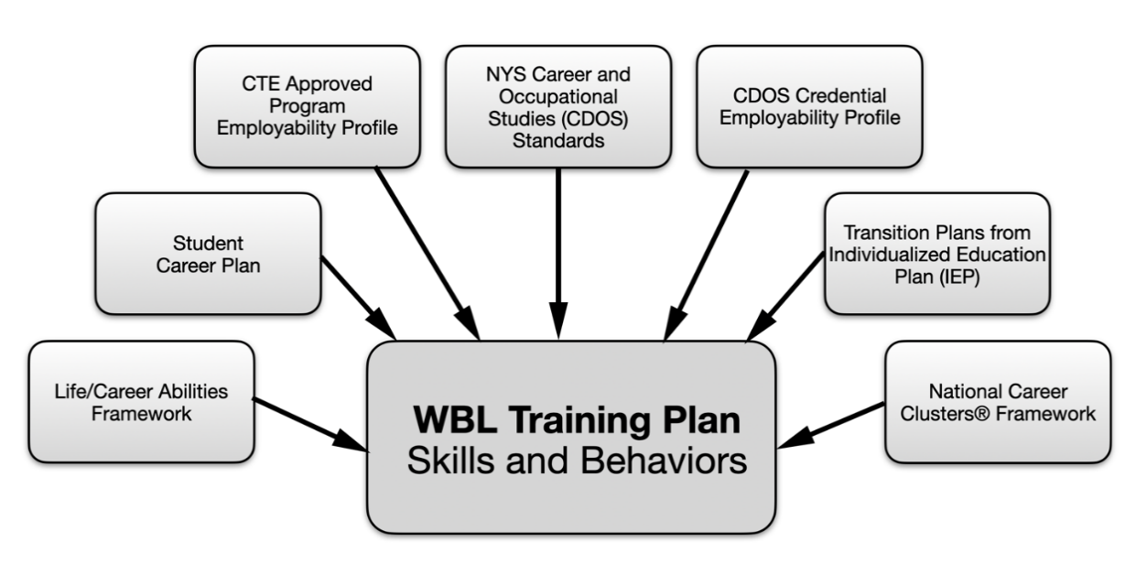
Career and technical education programs in New York State must align their curriculum with the Career Development and Occupational Studies (CDOS) learning standards and other applicable New York State learning standards.

NYSED-Approved CTE Programs provide completers eligibility for the CTE technical endorsement and CTE 4+1 diploma pathway option. An approved program contains a related series/combination of courses and experiences in a career and technical area. It includes an employability profile based on input from employers and industry standards. NYSED-approved CTE programs are required to provide opportunities for students to participate in WBL. The employability profile articulates expected learning outcomes, some of which can be integrated into the training plan. In most cases, the training plan will focus on the work-related and, where required, technical skills expected to be developed during the WBL experience. Depending on the program and work-based learning opportunity, students may only be developing workplace skills in an internship setting. Technical skills are required to be assessed in all co-op programs due to the nature of the program but should not be assessed in CEIP, GEWEP, WECEP, or any unregistered experiences.

The Career Development and Occupational Studies (CDOS) Commencement Credential is not a diploma but allows completers eligibility for the 4+1 diploma pathway option. It requires a career plan that documents attainment of the commencement level CDOS learning standards in the area of career exploration and development, integrated learning, and universal foundation skills. Option 1 includes at least 54 hours of WBL and a completed employability profile. For students focused on the CDOS credential, the Career Development and Occupational Studies learning standards are a source of learning expectations. The New York State Education Department provides a sample CDOS employability profile for students earning a CDOS credential with cross-referenced information to the Universal Foundation Skills of the CDOS standards.

The development and on-going review of student career plans, required by Section 100.2(j)(ii) of the Commissioner’s Regulations, offers students the opportunity to reflect on their pathways to graduation and beyond. Career plans, developed by students and their parents with school counselors to chart the growth of interests and goals, can provide information for the WBL Training Plan.

For students with disabilities, the transition planning required by Individualized Education Programs (IEPs) is a source of detail about career goals and learning expectations, which can contribute to the training plan.

The Life/Career Competencies Framework includes behavior rubrics on work-habits, social-emotional learning, and 21st Century skills, which may be appropriate for student WBL experiences.

For students in a WBL program and who are not involved in any other CTE instruction, a source of learning experiences is the National Career Clusters® Framework used by the U.S. Department of Labor and U.S. Department of Education. This framework defines career fields and provides skills in about 79 career pathways.

Evaluation
An essential step in WBL is to evaluate student learning by collecting feedback from the employee/mentor and WBL coordinator. The evaluation should be based on the personalized learning expectations of the training plan. It is important to develop a training plan that includes space to measure achievement in the development of technical skills and work-related skills and document total WBL hours completed.

Signatures
The training plan form should include places for signatures of agreement from the student, WBL coordinator, employer/mentor, and parent.

Adjusting Training Plan for Virtual and Remote WBL
Effective WBL makes experiences authentic, usually by having students work in a real-world setting performing assignments under the supervision of an employer/mentor. Unexpected interruptions, such as the extended school closure of 2020 or other obstacles, may make it more challenging to provide authentic WBL experiences. Two distinctly different categories of WBL may be utilized to give students career related experiences.

Remote Work-Based Learning: A WBL experience (including, but not necessarily limited to, an internship or a job shadow) where students complete an experience similar to what they would have completed on-site; however, the student does not go to the site. Students will complete responsibilities via telecommuting, e-mail, or other means. Students will work with a real organization and interact with an actual industry employer/mentor.

Virtual Work-Based Learning: A WBL experience where students learn work-related and (where appropriate) technical skills related to a job or career field. This would be done via a simulation, preferably created by and in conjunction with business and industry. Students will complete simulated experiences that mirror and teach skills needed for career success. However, students will not work with an actual industry employer/mentor or a real organization.

If remote or virtual WBL opportunities are unavailable, WBL coordinators can also work with teachers, administrators, and industry partners to provide experiences that would help achieve the goals of the training plan through experiences such as school-based enterprises, community-based projects, or employer-led digital projects.

