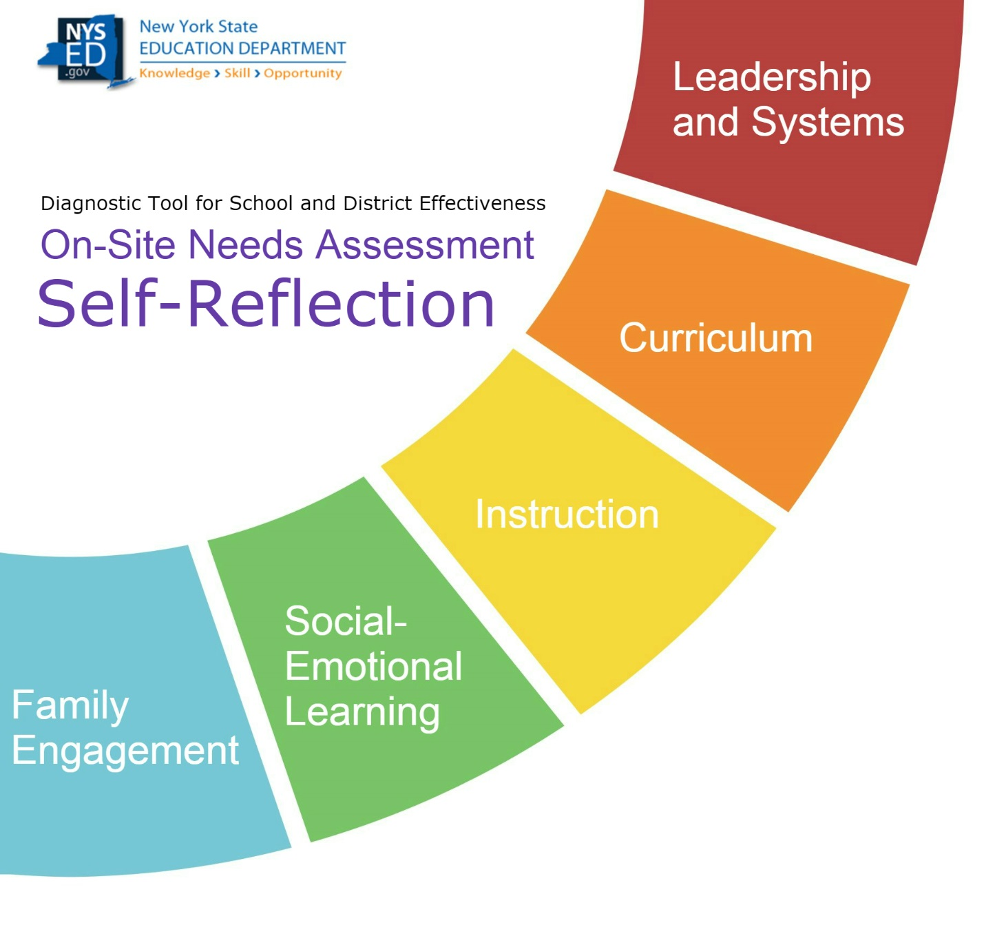
School
District
Principal

A Message to School/District Leaders:
The on-site DTSDE process is intended to delve into the factors that have contributed to the school being identified as a Comprehensive Support and Improvement (CSI) or Targeted Support and Improvement (TSI) school.

For the process to be successful, school staff will need to engage in an honest and thoughtful reflection about the internal barriers and challenges that exist so that strategies to address these can be developed.

The IIT will use this document to learn about the school AND to get a sense of the school’s ability to self-assess and understand the work ahead with accuracy. The IIT will follow up with aspects of the self-reflection during the needs assessment process.

Extraordinary Circumstances of the School
(Please use the space below to alert the IIT to any extraordinary circumstances related to the current operations of the school. An example of an extraordinary circumstance would be that the school had to be relocated to a temporary location for two months at the beginning of the school year because of flooding).

Name of those assisting in the completion of the Self-Reflection
Name (add rows if necessary) | Title

Instructions:
- Be sure to consider the QUALITY and EFFECTIVENESS of the school’s initiatives and the way in which it is organized when reflecting on the next steps needed for the school. The needs assessment process will not involve any use of checklists; instead, the IIT will look closely at the quality and effectiveness/impact when identifying needs.
Remember - IIT members will use this document to learn about the school AND to get a sense of the school’s ability to self-assess and understand the work ahead. School leaders should be prepared to answer questions based on the responses provided in this self-reflection.

Part 1: School Priorities
Identify the school’s top priorities (no more than five) for the year:

Priority # | School Priorities as Written by the School
1
2
3
4
5

Prompt: Have these priorities been shared with the staff, students, and parents? If so, how?
Priority # | How each has been shared with others
1
2
3
4
5

Part 2: Schoolwide Staffing Data
Schoolwide Data (use most current data unless otherwise indicated)
Grades Served |  |  | Number of Years Principal Assigned to School
Number of Assistant Principals |  |  | Number of Instructional Coaches
Number of Teachers |  |  | Number of Students
Staffing Ratios
Staffing Category |  | School’s Ratio |  | Recommended Ratio
Certified Librarians to students |  |  |  | 1 per school
Nurses to students |  |  |  | 1 nurse per school minimum, additional staffing needed depending on population
School Counselors to students |  |  |  | 1 school counselor for every 250 students
School Psychologists to students |  |  |  | 1 school psychologist for every 500-700 students
School Social Workers to students |  |  |  | 1 school social worker per 250 students (general education)  1 school social worker per 50 students (students with intensive needs)

For any instances that the school’s figures do not meet the recommended ratios, what has been the school’s approach toward providing necessary services? Complete the chart below
Area that Does Not Meet Recommended Ratio | School’s Approach
EXAMPLE: Certified Librarians | Teachers take their students to the library once a week. A parent volunteer staffs the library on Fridays.

Part 3: Curriculum
Instructions: Complete the chart below by first identifying the curriculum used by the school, and then completing the Curriculum Data sections for the grades served by the school. For example, a school serving students in grades 6-8 would complete both the K-6 section and the 7th and 8th grade section.
Curriculum Used by the School
Subject | Name of Curriculum | Grades Served
Curriculum Data Grades K-6 |  | % / #
% of K- 3 students who receive daily physical ed. for a min. total of 120 min. per week (not including recess)
% Grade 4-6 students who receive physical ed. 3 days/week for a min. total of 120 minutes/week (not including recess)
% of Grade 1-3 students who have 20% of the weekly time spent in school allocated to dance, music, theatre, and visual arts
% of Grade 4-6 students who have 10% of the weekly time spent in school be allocated to dance, music, and theatre and visual arts
Average number of minutes of Social Studies instruction per week in Grades 4 to 6
Average number of minutes of Science instruction per week in Grades 4 to 6
Curriculum Data Grades 7-8
% of Grade 7-8 students who receive physical education instruction equivalent to 3 periods for one semester and 2 periods for the other semester (not including recess)
% of Grades 7-8 students who receive 55 hours per year of instruction in dance, music, theatre, and visual arts taught by a certified arts instructor
% of 7th grade students enrolled in HS coursework
% of 8th grade students enrolled in HS coursework
Curriculum and Performance Data - HS
% of students who earn 5 or more credits during the school year
% of 12th grader students who have taken college entrance and/or college placement exams
% of 12th grade students who have passed at least one Regents exam with a score of 90 or higher
% of students last year who received Regents Diplomas with advanced designation
% of students enrolled in dual-credit coursework
% of current 12th grade students enrolled in an Advanced Placement (AP) course
% of current 11th grade students enrolled in an AP course
% of students enrolled in Career and Technical Education (CTE) courses
% of HS students who have more than one study hall a day
Prompt: Do the data above suggest that there is a need to expand curricular opportunities to students? If so, what do you see as a next step?
School’s Response:

Part 4: Ongoing School Improvement
- Did your school receive a District-led Diagnostic Tool for School and District Effectiveness (DTSDE) visit or complete a DTSDE self-reflection in 2017-18?
Yes: If you select YES, then proceed to questions 2-7 below
No: If you select NO, then skip questions 2-7 and continue to Part 5

- What work has your school done regarding Tenet 2, School Leadership, and, if applicable, the recommendation you received, since your last year’s DTSDE report?
School’s Response:

- What work has your school done regarding Tenet 3, Curriculum, and, if applicable, the recommendation you received, since your last year’s DTSDE report?
School’s Response:

- What work has your school done regarding Tenet 4, Instruction, and, if applicable, the recommendation you received, since your last year’s DTSDE report?
School’s Response:

- What work has your school done regarding Tenet 5, Social-Emotional Developmental Health, and, if applicable, the recommendation you received, since your last year’s DTSDE report?
School’s Response:

- What work has your school done regarding Tenet 6, Family and Community Engagement, and, if applicable, the recommendation you received, since your last year’s DTSDE report?
School’s Response:

- Based on your experiences since last year’s DTSDE visit, what have you learned about implementing recommendations at your school?
School’s Response:

Part 5: Whole School Reflection
1. Identify three to five things the school believes it does well:
1.
2.
3.

2. Identify three to five things that the school believes are internal barriers or challenges that are making it difficult for the school to reach its potential:
1.
2.
3.

3. Identify three to five things that the school believes must happen that are currently not happening:
1.
2.
3.

Appropriate Staffing for School Libraries - http://www.ala.org/aasl/sites/ala.org.aasl/files/content/aaslissues/positionstatements/AASL_Position%20Statement_Appropriate%20Staffing_2016-06-25.pdf
School Nurse Workload: Staffing for Safe Care https://www.nasn.org/advocacy/professional-practice-documents/position-statements/ps-workload
American School Counselor Association https://www.schoolcounselor.org/press
NASP Practice Model - http://www.nasponline.org/assets/Documents/Standards%20and%20Certification/Standards/2_PracticeModel.pdf
The NASW Standards for School Social Work Services - https://www.socialworkers.org/LinkClick.aspx?fileticket=1Ze4-9-Os7E%3D&portalid=0

