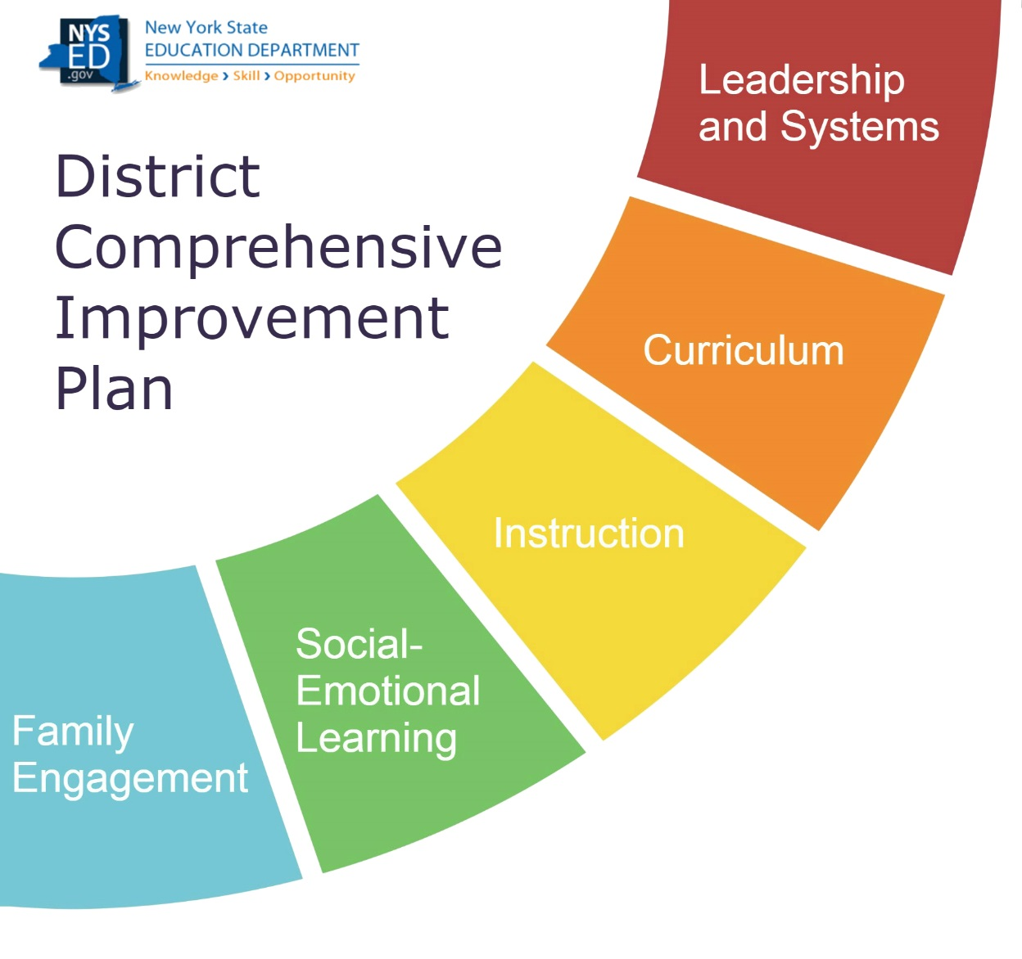

DCIP Planning Document for 2022-23 DCIP
District

A Message to District Leaders:
The District Comprehensive Improvement Plan (DCIP) Planning Document is designed to help districts consider the conditions within the District that need attention when developing the 2022-23 DCIP.
The DCIP Planning Document provides the District with the opportunity to reflect on the way in which the schools within the District are organized to promote achievement. While this document is intended to serve as a foundation for the DCIP, NYSED strongly encourages districts to take a deeper look at relevant data across the District to best support the District’s ability to identify specific solutions for their unique needs. This document will involve:
- Evaluating the impact of COVID-19
- Considering the effectiveness of the 2021-22 DCIP
- Understanding local data
- Reviewing the District’s vision, values, and aspirations
NYSED encourages districts to be strategic in how they address their needs and to be mindful of the number of priorities and changes they attempt to address each year. When developing your 2022-23 DCIP, consider ways the Priorities intersect so that the DCIP is aligned to support the pressing needs of the District. Rather than identifying multiple independent Priorities within the DCIP, consider ways that Priorities could be supported through a strategic approach that allows for the work being done in one area to support the work being done in another area.
Contents
Section 1: Considering What was Learned in 2021-22 3
Evaluating the Impact of COVID-19 3
Evaluating the Success of the 2021-22 DCIP 3
Considering the Effectiveness of Previous Resource Decisions 5
Understanding Local Data 6
Listening to Students 7
Examining Equity 7
Section 2: District’s Vision, Values, and Aspirations 9
Section 3: Putting it all together 10
Priority 1: 10
Priority 2: 10
Priority 3: 10
Priority 4 (if applicable) 11
Priority 5 (if applicable): 11
NEXT STEPS 11

Section 1: Considering What was Learned in 2021-22

Evaluating the Impact of COVID-19
What needs have been identified as a result the COVID-19 pandemic?
To what extent is the identified subgroup(s) disproportionally impacted by the issues identified in the previous response?
What has the District learned through its efforts to address these needs?
How will these lessons learned be incorporated in the 2022-23 DCIP?

Evaluating the Success of the 2021-22 DCIP
Refer to the 2021-22 DCIP to complete the information below.
Priority 1 in 2021-22 DCIP:
Was the District able to achieve the End-of-Year Outcomes identified for this Priority?
If the identified outcomes were not achieved, in the space below, identify factors that may have contributed to the District not achieving these outcomes.
Factors

Priority 2 in 2021-22 DCIP:
Was the District able to achieve the End-of-Year Outcomes identified for this Priority?
If the identified outcomes were not achieved, in the space below, identify factors that may have contributed to the District not achieving these outcomes.
Factors

Priority 3 in 2021-22 DCIP:
Was the District able to achieve the End-of-Year Outcomes identified for this Priority?
If the identified outcomes were not achieved, in the space below, identify factors that may have contributed to the District not achieving these outcomes.
Factors

Priority 4 in 2021-22 DCIP (if applicable):
Was the District able to achieve the End-of-Year Outcomes identified for this Priority?
If the identified outcomes were not achieved, in the space below, identify factors that may have contributed to the District not achieving these outcomes.
Factors

Priority 5 in 2021-22 DCIP (if applicable):
Was the District able to achieve the End-of-Year Outcomes identified for this Priority?
If the identified outcomes were not achieved, in the space below, identify factors that may have contributed to the District not achieving these outcomes.
Factors

After reviewing your success in achieving the 2021-22 DCIP Priorities, what lessons have you learned that can be incorporated into your 2022-23 DCIP

Considering the Effectiveness of Previous Resource Decisions
Identify the top three areas where the District directed its 2021-22 Title 1 1003(a) District-level Improvement Funds.
#1 Recipient/Use of District Improvement Funds:
What was your goal in directing funds in this manner?
Have you met this goal? How do you know?
What practices (including student practices and teacher practices) look different in the District now as a result of this expenditure?

#2 Recipient/Use of District Improvement Funds:
What was your goal in directing funds in this manner?
Have you met this goal? How do you know?
What practices (including student practices and teacher practices) look different in the District now as a result of this expenditure?

#3 Recipient/Use of District Improvement Funds:
What was your goal in directing funds in this manner?
Have you met this goal? How do you know?
What practices (including student practices and teacher practices) look different in the District now as a result of this expenditure?

After considering the effectiveness of previous resource allocation decisions, what lessons have you learned that can be incorporated into your 2022-23 DCIP?

Understanding Local Data
Use the space below to include at least five local data points that the District has collected that are relevant to understanding the District. These could include:
- State-collected data from the NYSED District Report Card, such as the teacher turnover rate
- District-collected data, such as survey results
- Districtwide academic assessment data
- Student engagement/attendance data
- Student social-emotional health data
When possible, consider data from the 2021-22 school year.
Example: District survey data indicated that 44% of students say that they do not feel challenged in class.
District-level Data

Listening to Students
Identified schools are interviewing students in advance of writing their annual plans, and Districts with identified schools are being asked to reflect on the feedback provided by students as part of their DCIP. Districts without identified schools are welcome to pursue Student Interviews as well, and may find the resource below helpful: http://www.nysed.gov/common/nysed/files/programs/accountability/interviewing-students-in-advance-of-developing-the-scep_2.pdf

If your District conducted Student Interviews, what themes emerged from this process? If no interviews were conducted, the District may leave this section blank.

Examining Equity
Identified schools are completing an Equity Self-Reflection in advance of writing their annual plans, and Districts with identified schools are being asked to consider the discussions that occurred within their identified schools when developing their DCIP. Districts without identified schools are welcome to incorporate the Equity Self-Reflection into their DCIP as well, and may find the resource below helpful: http://www.nysed.gov/common/nysed/files/programs/accountability/equity-self-reflection-for-2022-23-scep.docx

If schools within your District completed the Equity Self-Reflection, what themes emerged from this process? If schools did not complete this document, the District may leave this section blank.

Section 2: District’s Vision, Values, and Aspirations
- What is the District’s vision?
- In recognition that sometimes vision statements may not be a current reflection of the District’s values and aspirations, is there anything else important to know about what the District values and aspires to be that is not captured in the current vision?
- Review your responses to Section 1. What themes emerge that let you know that you have made progress toward the vision, values, and aspirations of the District?
- Review your responses to Section 1. What themes emerge that let you know that you still have work to be done toward the vision, values, and aspirations of the District?
- If Student Interviews were conducted, what themes emerged through the Student Interviews that let you know that you have made progress toward the vision, values, and aspirations of the District? What themes emerged that let you know that you still have work to be done toward the vision, values, and aspirations of the District? Districts that did not conduct Student Interviews may leave this section blank.
- If the Equity Self-Reflection for Identified Schools was completed within your District, what themes emerged that let you know that you have made progress toward the vision, values, and aspirations of the District? What themes emerged that let you know that you still have work to be done toward the vision, values, and aspirations of the District? Districts that did not complete the Equity Self-Reflection for Identified Schools may leave this section blank.

Section 3: Putting it all together
Review your responses to sections 1 and 2 to identify 3 to 5 priorities for the 2022-23 DCIP. Identify the priorities below and indicate how those priorities support the themes that emerged in the previous sections.

Priority 1:
What will the District prioritize to extend success in 2022-23?
This Priority helps support (indicate all that apply)
Impact of COVID-19 (Section 1 – Evaluating the Impact of COVID-19)
Recent Data (Section 1 – Understanding Local Data)
The District’s Vision (Section 2, Question 1)
The District’s Values and Aspirations not captured through Vision (Section 2, Question 2)
Themes from Student Interviews (Section 2, Question 5)
Themes from the Equity Self-Reflection (Section 2, Question 6)

Priority 2:
What will the District prioritize to extend success in 2022-23?
This Priority helps support (indicate all that apply)
Impact of COVID-19 (Section 1 – Evaluating the Impact of COVID-19)
Recent Data (Section 1 – Understanding Local Data)
The District’s Vision (Section 2, Question 1)
The District’s Values and Aspirations not captured through Vision (Section 2, Question 2)
Themes from Student Interviews (Section 2, Question 5)
Themes from the Equity Self-Reflection (Section 2, Question 6)

Priority 3:
What will the District prioritize to extend success in 2022-23?
This Priority helps support (indicate all that apply)
Impact of COVID-19 (Section 1 – Evaluating the Impact of COVID-19)
Recent Data (Section 1 – Understanding Local Data)
The District’s Vision (Section 2, Question 1)
The District’s Values and Aspirations not captured through Vision (Section 2, Question 2)
Themes from Student Interviews (Section 2, Question 5)
Themes from the Equity Self-Reflection (Section 2, Question 6)

Priority 4 (if applicable)
What will the District prioritize to extend success in 2022-23?
This Priority helps support (indicate all that apply)
Impact of COVID-19 (Section 1 – Evaluating the Impact of COVID-19)
Recent Data (Section 1 – Understanding Local Data)
The District’s Vision (Section 2, Question 1)
The District’s Values and Aspirations not captured through Vision (Section 2, Question 2)
Themes from Student Interviews (Section 2, Question 5)
Themes from the Equity Self-Reflection (Section 2, Question 6)

Priority 5 (if applicable):
What will the District prioritize to extend success in 2022-23?
This Priority helps support (indicate all that apply)
Impact of COVID-19 (Section 1 – Evaluating the Impact of COVID-19)
Recent Data (Section 1 – Understanding Local Data)
The District’s Vision (Section 2, Question 1)
The District’s Values and Aspirations not captured through Vision (Section 2, Question 2)
Themes from Student Interviews (Section 2, Question 5)
Themes from the Equity Self-Reflection (Section 2, Question 6)

NEXT STEPS
You have now completed the DCIP planning document. When developing your 2022-23 DCIP, please take into consideration your reflection on the District’s vision, values, and aspirations and what the District learned from the past school year to determine the best strategies to pursue. The Priorities identified in this document should correspond with the Priorities in your DCIP.
Please submit this document to dcip@nysed.gov when you submit your 2022-23 DCIP.

