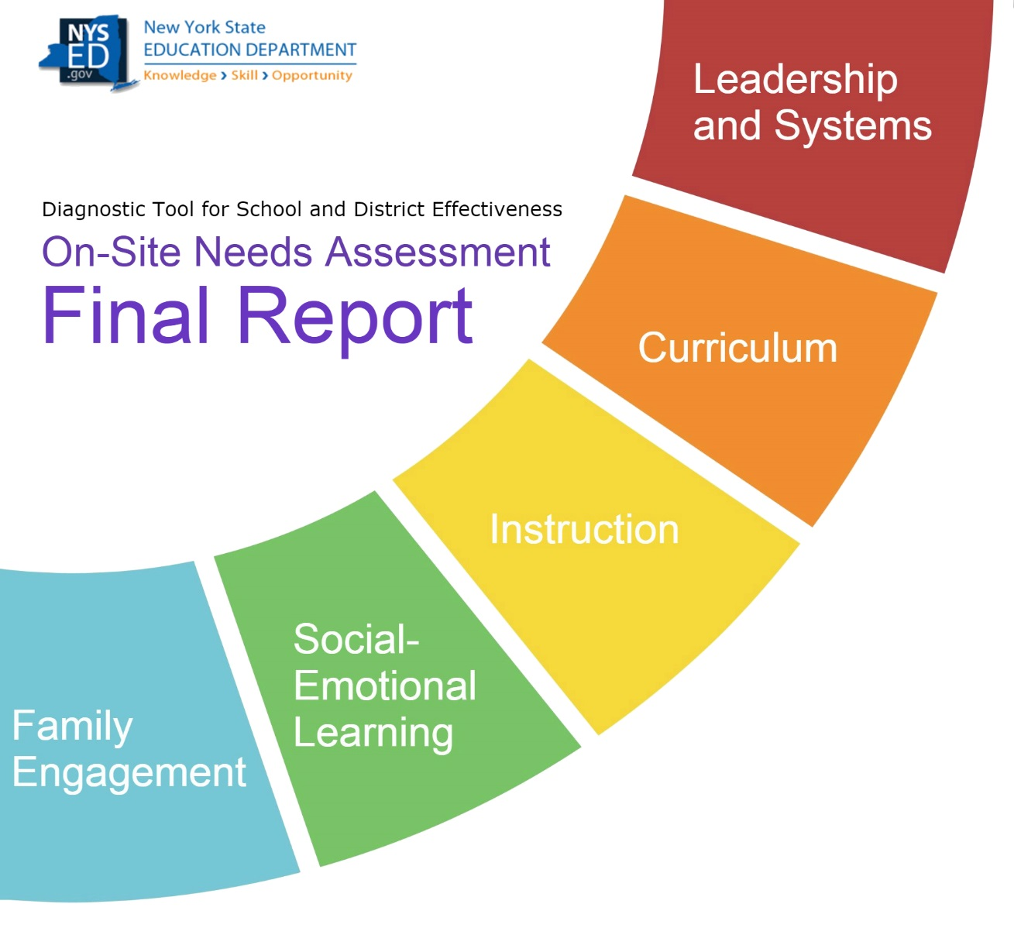

BEDS Code
School Name
School Address
District Name
Principal
Dates of Visit

NEEDS ASSESSMENT TEAM MEMBERS
Name | Role

Purpose Of The Visit
This school was identified as a Targeted Support and Improvement School with at least one subgroup that would benefit from additional support. Because of this identification, the District conducted an on-site Needs Assessment. The visit is intended to help the school identify areas of need that are preventing the school from reaching its potential and provide several recommendations that can be accomplished and demonstrate the school’s commitment to improvement.

The report provides a critical lens to help the school best focus its efforts.

School Identification Status
The school has been identified as needing Targeted Support and Improvement for the following subgroups:
- Subgroup 1 edit as necessary

Information About The Visit
- INSERT NAME served as the lead reviewer on the district-led team.
- The team visited a total of INSERT NUMBER classrooms during the visit.
- The Lead Reviewer visited INSERT NUMBER classrooms with the principal during the visit.
- Team members conducted interviews with students, staff, and parents.
- Team members examined documents provided by the school, including curriculum maps, lesson plans, schoolwide data, teacher feedback, and student work. Delete any that do not apply.
- In advance of the visit, the school provided results of a student survey that INSERT NUMBER OF STUDENTS WHO RESPONDED students (INSERT PERCENT HERE percent) completed.
- In advance of the visit, the school provided results of a staff survey that INSERT NUMBER OF STAFF WHO RESPONDED staff members (INSERT PERCENT HERE percent) completed.
- In advance of the visit, the school provided results of a parent survey that INSERT NUMBER OF PARENTS WHO RESPONDED parents (INSERT PERCENT HERE percent) completed.
- DELETE SURVEY INFO AS NEEDED
- INSERT ANY EXTRAORDINARY CIRCUMSTANCES THAT EXIST AT THE SCHOOL, along with how the circumstances impacted the visit, SUCH AS “A flood several months ago has caused the kindergarten students to be relocated to a neighboring school. The IIT did not visit kindergarten classrooms during its visit.”
- INSERT ANY EXTRAORDINARY CIRCUMSTANCES THAT OCCURRED DURING THE VISIT, SUCH AS “A bomb threat resulted in the school being evacuated for several hours during the second day of the visit. As a result, the parent focus group scheduled for that time occurred after school instead.

Successes Within The School That The School Should Build Upon:
- In this area –Identify three to five things that you would like to commend the school on. Be mindful of how you phrase this so that there are no contradictions with the narrative that follows. Also, be mindful of endorsing activities if you are not confident in the quality or effectiveness of these activities.

Recommendations
The Recommendations below were discussed with the principal before being finalized and were left at the conclusion of the visit for the school to address immediately.

Short-Term Recommendation #1
Area: Schoolwide Systems and Organization
Area: School Leadership
Area: Curriculum
Area: Instruction
Area: Social-Emotional Learning
Area: Family and Community Engagement
Area: Students with Disabilities
Area: English Language Learners
Area: Other (indicate)
Recommendation:
Delete this text before making the report final –
In this section, provide the recommendation left on-site with the school.
Rationale that led to the Recommendation:
Delete this text before making the report final –
In this section, provide your reasons for why this Recommendation is appropriate for the school. These reasons should have been confirmed with the principal while on-site.
The first sentence should serve as an introductory statement.
Multiple bullets may be used, though one bullet is sufficient, provided the evidence is presented in a cohesive manner.
- Rationale #1

Short-Term Recommendation #2
Area: Schoolwide Systems and Organization
Area: School Leadership
Area: Curriculum
Area: Instruction
Area: Social-Emotional Learning
Area: Family and Community Engagement
Area: Students with Disabilities
Area: English Language Learners
Area: Other (indicate)
Recommendation:
Delete this text before making the report final –
In this section, provide the recommendation left on-site with the school.
Rationale that led to the Recommendation:
Delete this text before making the report final –
In this section, provide your reasons for why this Recommendation is appropriate for the school. These reasons should have been confirmed with the principal while on-site.
The first sentence should serve as an introductory statement.
Multiple bullets may be used, though one bullet is sufficient, provided the evidence is presented in a cohesive manner.
- Rationale #1

Short-Term Recommendation #3
Area: Schoolwide Systems and Organization
Area: School Leadership
Area: Curriculum
Area: Instruction
Area: Social-Emotional Learning
Area: Family and Community Engagement
Area: Students with Disabilities
Area: English Language Learners
Area: Other (indicate)
Recommendation:
Delete this text before making the report final –
In this section, provide the recommendation left on-site with the school.
Rationale that led to the Recommendation:
Delete this text before making the report final –
In this section, provide your reasons for why this Recommendation is appropriate for the school. These reasons should have been confirmed with the principal while on-site.
The first sentence should serve as an introductory statement.
Multiple bullets may be used, though one bullet is sufficient, provided the evidence is presented in a cohesive manner.
- Rationale #1

Short-Term Recommendation #4
Area: Schoolwide Systems and Organization
Area: School Leadership
Area: Curriculum
Area: Instruction
Area: Social-Emotional Learning
Area: Family and Community Engagement
Area: Students with Disabilities
Area: English Language Learners
Area: Other (indicate)
Recommendation:
Delete this text before making the report final –
In this section, provide the recommendation left on-site with the school.
Rationale that led to the Recommendation:
Delete this text before making the report final –
In this section, provide your reasons for why this Recommendation is appropriate for the school. These reasons should have been confirmed with the principal while on-site.
The first sentence should serve as an introductory statement.
Multiple bullets may be used, though one bullet is sufficient, provided the evidence is presented in a cohesive manner.
- Rationale #1

Short-Term Recommendation #5
Area: Schoolwide Systems and Organization
Area: School Leadership
Area: Curriculum
Area: Instruction
Area: Social-Emotional Learning
Area: Family and Community Engagement
Area: Students with Disabilities
Area: English Language Learners
Area: Other (indicate)
Recommendation:
Delete this text before making the report final –
In this section, provide the recommendation left on-site with the school.
Rationale that led to the Recommendation:
Delete this text before making the report final –
In this section, provide your reasons for why this Recommendation is appropriate for the school. These reasons should have been confirmed with the principal while on-site.
The first sentence should serve as an introductory statement.
Multiple bullets may be used, though one bullet is sufficient, provided the evidence is presented in a cohesive manner.
- Rationale #1

Short-Term Recommendation #6
Area: Schoolwide Systems and Organization
Area: School Leadership
Area: Curriculum
Area: Instruction
Area: Social-Emotional Learning
Area: Family and Community Engagement
Area: Students with Disabilities
Area: English Language Learners
Area: Other (indicate)
Recommendation:
Delete this text before making the report final –
In this section, provide the recommendation left on-site with the school.
Rationale that led to the Recommendation:
Delete this text before making the report final –
In this section, provide your reasons for why this Recommendation is appropriate for the school. These reasons should have been confirmed with the principal while on-site.
The first sentence should serve as an introductory statement.
Multiple bullets may be used, though one bullet is sufficient, provided the evidence is presented in a cohesive manner.
- Rationale #1

Areas Of Need To Be Addressed For Long-Term Success

Tenets 1 and 2 Systems, Organization, and Leadership
- Area #1
- In this section, identify up to EIGHT pieces of additional feedback to provide the school pertaining to the systems within the school and how the school is organized to make improvements, including feedback on:
  - The pillars found in Tenet 1 of the DTSDE Framework:
    - 1A Ongoing Evaluation and Continuous Improvement
    - 1B Intervention and Identification
    - 1C Supports for Student Subgroups
    - 1D Attendance
    - 1E Equity
    - 1F Staff Collaboration and Support
  - The pillars found in Tenet 2 of the DTSDE Framework:
    - 2A Awareness and Problem-Solving
    - 2B Ensures a Culture and Climate of Success
    - 2C Promotes a Shared Vision for Learning and Achievement
    - 2D Provides High-Quality Instructional Leadership
    - 2E. Effectively Manages Resources
    - 2F. Cultivates Partnerships

- The text that will go in this section will be both:
  - Things the school may not be aware of
  - Things that will not be news to the school, but are important pieces of feedback that the team is compelled to share because progress will be difficult as long as what is described is unaddressed.
- The items in this section will not include descriptions of the school’s process, unless it is being shared to present a point about an area of need.
- The first sentence for each bullet should be a finding and should be in BOLD. The finding should be the team’s conclusion. The remaining sentences in the bullet should provide evidence and examples to support the finding.
- THESE MUST BE SCHOOL SPECIFIC.
- This should include the finding and telling evidence that represents an area of need and has been deemed too critical to ignore but may have not been reflected in a Recommendation.
- Each bullet should be approximately 2-4 sentences.
- Areas of need identified in this section should have been shared with the school while on-site, so that nothing that appears here will be new information to the school.
- No recommendations regarding how to address these things are necessary, though in one or two instances, you may want to include a last sentence that provides some guidance on what could be done later along the lines of “In the future, the school leaders will need to (address/ensure) [whatever the issue is that was noted in the previous sentences].”

Tenets 3 and 4: Curriculum and Instruction at the School

- Area #1
- In this section, identify up to EIGHT pieces of additional feedback to provide the school pertaining to school leadership and how the school is organized, including feedback on:
The DTSDE Framework Tenet 3 Pillars:
  - How linked the curriculum is to what has been done previously and what comes next (3A. Curriculum Coherence and Progression)
  - How activities and lessons allow students to dig deep (3B. Depth)
  - How the school has made sure the curriculum is not narrowed (3B. Breadth)
  - How relevant, challenging, and interesting the lessons are designed to be (3C. Relevance, Challenge, and Enjoyment
  - The structure and focus of lessons (3D. Lesson Focus and Organization
  - How activities stretch students’ thinking by asking students to be active learners and do things that are cognitively challenging (3E. Activities)
  - How materials help expand students’ thinking (3E. Materials)
  - How the teachers consider what is taught and when it is taught based on the students they teach (3F. Evaluation, Adaptation, and Flexibility)
The DTSDE Framework Tenet 4 Pillars:
- How the teachers interact with students (4A and 4B)
- How students interact with other students (4A and 4B)
- How teachers stretch students’ thinking through their interactions (4C and 4E)
- How teachers’ communications assist students’ understanding (4D)
- How teachers’ actions (such as modeling) assist students’ understanding (4D)
- How teachers know students’ are learning (4F)
- How students know that they are learning (4F)

- THESE MUST BE SCHOOL SPECIFIC.
- The text that will go in this section will be both:
  - Things the school may not be aware of
  - Things that will not be news to the school, but are important pieces of feedback that the team is compelled to share because progress will be difficult as long as what is described is unaddressed.
- The items in this section will not include descriptions of the school’s process, unless it is being shared to present a point about an area of need.
- The first sentence for each bullet should be a finding and should be in BOLD. The finding should be the team’s conclusion. The remaining sentences in the bullet should provide evidence and examples to support the finding.
- This should include the finding and telling evidence that has been deemed too critical to ignore but may have not been reflected in a Recommendation.
- Each bullet should be approximately 2-4 sentences.
- Areas of need identified in this section should have been shared with the school while on-site, so that nothing that appears here will be new information to the school.
- No recommendations regarding how to address these things are necessary, though in one or two instances, you may want to include a last sentence that provides some guidance on what could be done later along the lines of “In the future, the school leaders will need to (address/ensure) [whatever the issue is that was noted in the previous sentences].”

Tenet 5: Social-Emotional Learning at the School
- Area #1
In this section, identify up to FOUR pieces of additional feedback to provide the school pertaining to the school’s support of student social-emotional learning, including feedback on the Tenet 5 pillars within the DTSDE Framework:
  - Systems for SEL (5A)
  - Partnerships for SEL (5C)
  - Supportive Climate for SEL, including
    - Students’ sense of belonging (5B)
    - Students’ connection to other students, the material, and teachers (5B)
    - Students’ enthusiasm for what they do (5B)
    - Students’ sense of self-direction (5B)
  - Partnerships for SEL (5C)
- THESE MUST BE SCHOOL SPECIFIC.
- The text that will go in this section will be both:
  - Things the school may not be aware of
  - Things that will not be news to the school, but are important pieces of feedback that the team is compelled to share because progress will be difficult as long as what is described is unaddressed.
- The items in this section will not include descriptions of the school’s process, unless it is being shared to present a point about an area of need.
- The first sentence for each bullet should be a finding and should be in BOLD. The finding should be the team’s conclusion. The remaining sentences in the bullet should provide evidence and examples to support the finding.
- This should include the finding and telling evidence that has been deemed too critical to ignore but may have not been reflected in a Recommendation.
- Each bullet should be approximately 2-4 sentences.
- Areas of need identified in this section should have been shared with the school while on-site, so that nothing that appears here will be new information to the school.
- No recommendations regarding how to address these things are necessary, though in one or two instances, you may want to include a last sentence that provides some guidance on what could be done later along the lines of “In the future, the school leaders will need to (address/ensure) [whatever the issue is that was noted in the previous sentences].”

Tenet 6: Family and Community Engagement
- Area #1
In this section, identify up to FOUR pieces of additional feedback to provide the school pertaining to the school’s systems for Family and Community Engagement, including feedback on the Tenet 6 pillars within the DTSDE Framework:
  - Systems for Communication (6A)
  - Systems for Engagement and Empowerment (6B)
  - Systems for Cultivating Relationships and Bridging Differences (6C)
  - Systems for Continuous Quality Improvement (6D)
- THESE MUST BE SCHOOL SPECIFIC.
- The text that will go in this section will be both:
  - Things the school may not be aware of
  - Things that will not be news to the school, but are important pieces of feedback that the team is compelled to share because progress will be difficult as long as what is described is unaddressed.
- The items in this section will not include descriptions of the school’s process, unless it is being shared to present a point about an area of need.
- The first sentence for each bullet should be a finding and should be in BOLD. The finding should be the team’s conclusion. The remaining sentences in the bullet should provide evidence and examples to support the finding.
- This should include the finding and telling evidence that has been deemed too critical to ignore but may have not been reflected in a Recommendation.
- Each bullet should be approximately 2-4 sentences.
- Areas of need identified in this section should have been shared with the school while on-site, so that nothing that appears here will be new information to the school.
- No recommendations regarding how to address these things are necessary, though in one or two instances, you may want to include a last sentence that provides some guidance on what could be done later along the lines of “In the future, the school leaders will need to (address/ensure) [whatever the issue is that was noted in the previous sentences].”

Areas of Need Shared by Stakeholders
- Area #1
- In this section, identify up to SIX areas of need identified by students from the identified subgroup OR parents of students from the identified subgroup.
- If there are no trends among the feedback provided, this section can be deleted.
- This feedback is learned from talking to parents and students about their thoughts on the school’s areas of need. Though this section is dedicated to areas of need, when applicable, it may be useful to present positive feedback alongside areas of need so that this section is not a litany of complaints. For example, you could say “Parents interviewed shared that they enjoyed the school’s multicultural night and wished there were more school events that brought together the school community,” rather than “Parents wished there were more events that brought together the school community.”
- THESE MUST BE SCHOOL SPECIFIC.
- The text that will go in this section will be both:
  - Things the school may not be aware of
  - Things that will not be news to the school, but are important pieces of feedback that the team is compelled to share because progress will be difficult as long as what is described is unaddressed.
- The items in this section will not include descriptions of the school’s process, unless it is being shared to present a point about an area of need.
- The first sentence for each bullet should be a finding and should be in BOLD. The remaining sentences in the bullet should provide evidence and examples to support the finding.
- Items identified in this section should have been shared with the school while on-site, so that nothing that appears here will be new information to the school.
- Reviewers must distinguish between feedback that is unique to one student or parent AND feedback that is relevant to provide to the school to assist in their improvement efforts by triangulating evidence.
- Each bullet should be approximately 2-4 sentences.
- No recommendations regarding how to address these things are necessary. In addition, do not use the phrase “in the future, the school leaders will need…” since that could cause confusion regarding who is providing that guidance.

